**Lab 1: HTML**

1. **Display your name as plain text in a web browser.**

<!DOCTYPE html>

<html lang="en">

<head>

<meta charset="UTF-8">

<meta name="viewport" content="width=device-width, initial-scale=1.0">

<title>PlainText</title>

</head>

<body>

Raunak Tuladhar

<hr>

<footer>

Name: Raunak Tuladhar <br>

Section: A <br>

Roll_no: 21-00011-5

</footer>

</body>

</html>

**Output:**

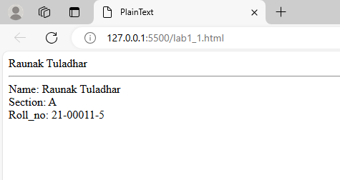

1. **Display your name in a web browser declared inside the body.**

<!DOCTYPE html>

<html lang="en">

<head>

<meta charset="UTF-8">

<meta name="viewport" content="width=device-width, initial-scale=1.0">

<title>Display name declared inside body</title>

</head>

<body>

<p>Raunak Tuladhar</p>

<hr>

<footer>

Name: Raunak Tuladhar <br>

Section: A <br>

Roll_no: 21-00011-5

</footer>

</body>

</html>

**Output:**

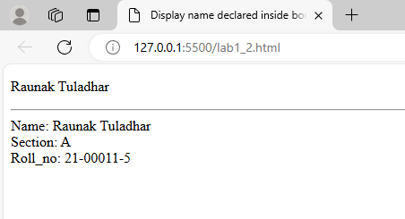

1. **Write a complete source code to demonstrate the use of HTML, head, title, and body tags.**

<html>

<head>

<title>Demonstration of html, head, title and body tag</title>

</head>

<body>

<p>Raunak Tuladhar</p>

<hr>

<footer>

Name: Raunak Tuladhar <br>

Section: A <br>

Roll_no: 21-00011-5

</footer>

</body>

</html>

**Output:**

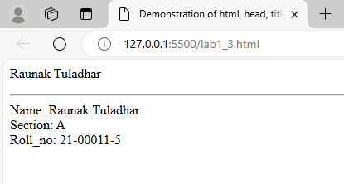

1. **Write a source code to demonstrate whitespace collapsing.**

<!DOCTYPE html>

<html lang="en">

<head>

<meta charset="UTF-8">

<meta name="viewport" content="width=device-width, initial-scale=1.0">

<title>Whitespace Collapsing</title>

</head>

<body>

This is an example of Whitespace Collapsing. <br>

This space&nbsp;won't collapse.

</body>

</html>

**Output:**

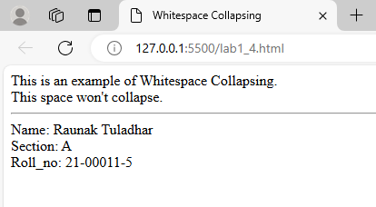

1. **Create two paragraphs. Paragraph 1 with the heading "Management Colleges in Nepal" and Paragraph 2 with the heading "Engineering Colleges in Nepal." Heading of Paragraph 2 must be smaller than the heading of Paragraph 2. Use various HTML tags like b, i, sup, sub, small, strong, abbr, acronym, blockquote with cite attribute, cite, q inside the paragraphs.**

<!DOCTYPE html>

<html lang="en">

<head>

<meta charset="UTF-8">

<meta name="viewport" content="width=device-width, initial-scale=1.0">

<title>Two paragraphs</title>

</head>

<body>

<hr>

<footer>

Name: Raunak Tuladhar <br>

Section: A <br>

Roll_no: 21-00011-5

</footer>

</body>

</html>

**Output:**

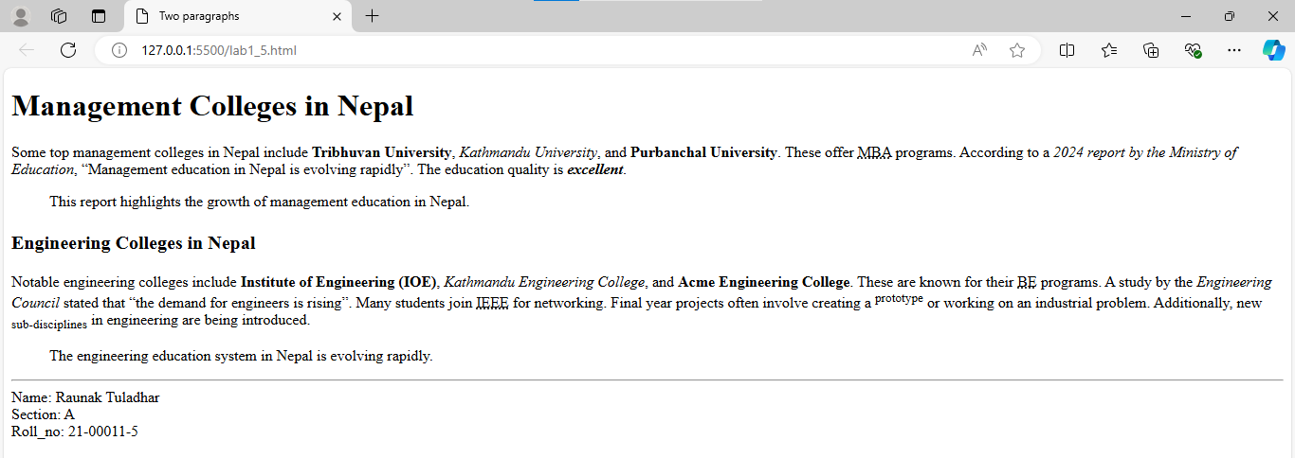

1. **Create an HTML page to display your bio data using <pre> tag. (Don’t use table).**

<!DOCTYPE html>

<html lang="en">

<head>

<meta charset="UTF-8">

<meta name="viewport" content="width=device-width, initial-scale=1.0">

<title>Document</title>

</head>

<body>

<pre>

Name: Raunak TUladhar

Email: raunaktuladhar13@gmail.com

Phone: +977 - 9861585891

Address: Asan-27, Kathmandu

Professional Summary:

Innovative, passionate, and detail-oriented professional with knowledge of Information Technology

and experience in aligning technology solutions with business objectives.

Skills:

- Basic Web Development, C/C++ coding

- Graphics Designing

Academic Information:

- BSc. CSIT - Prime College, Nayabazar, KTM (5th Semester Ongoing)

- 10+2 (Science) - Aroma College, Bharatpur (3.26 GPA)

Courses/Workshops/Projects:

- Python

- Graphics Design

- HTML, CSS, JS

- Student Management System using C++

Hobbies & Interests:

- Cycling

- Gaming

</pre>

<hr>

<footer>

Name: Raunak Tuladhar <br>

Section: A <br>

Roll_no: 21-00011-5

</footer>

</body>

</html>

**Output:**

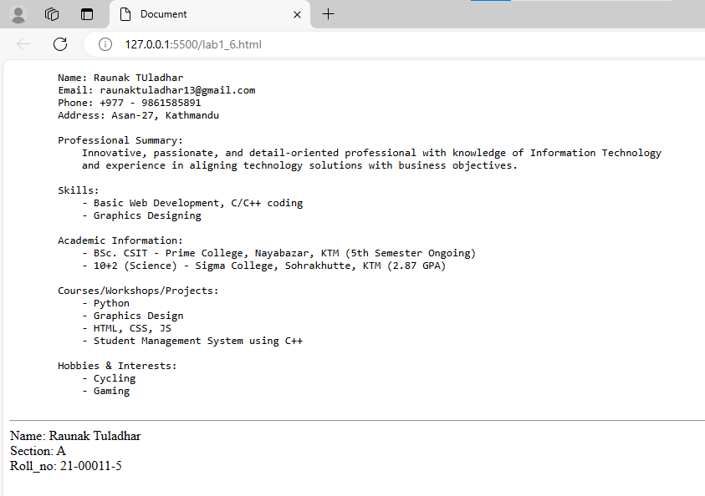

1. **Write HTML code to demonstrate the use of**

**a. code**

**b. kbd**

**c. var**

**d. samp**

<!DOCTYPE html>

<html lang="en">

<head>

<meta charset="UTF-8">

<meta name="viewport" content="width=device-width, initial-scale=1.0">

<title>HTML Tags: code, kbd, var, samp</title>

</head>

<body>

<h1>Demonstrating the Use of HTML Tags: <code>, <kbd>, <var>, and <samp></h1>

<h2>1. The code tag</h2>

<p>The <code>code</code> tag is used to define a piece of computer code. Example:</p>

<p>Here is an example of inline code: <code>print("Hello, World!")</code></p>

<h2>2. The kdb tag</h2>

<p>The <kbd>kbd</kbd> tag is used to represent user input, typically from a keyboard. Example:</p>

<p>To save a file, press <kbd>Ctrl</kbd> + <kbd>S</kbd>.</p>

<h2>3. The var tag</h2>

<p>The <var>var</var> tag is used to define a variable in a mathematical expression or in a piece of code. Example:</p>

<p>In the formula <var>x</var> + <var>y</var> = <var>z</var>, <var>x</var>, <var>y</var>, and <var>z</var> are variables.</p>

<h2>4. The samp tag</h2>

<p>The <samp>samp</samp> tag is used to define sample output from a computer program. Example:</p>

<p>Sample output from a program might look like this: <samp>Error: File not found</samp></p>

<br>

<hr>

<footer>

Name: Raunak Tuladhar <br>

Section: A <br>

Roll_no: 21-00011-5

</footer>

</body>

</html>

**Output:**

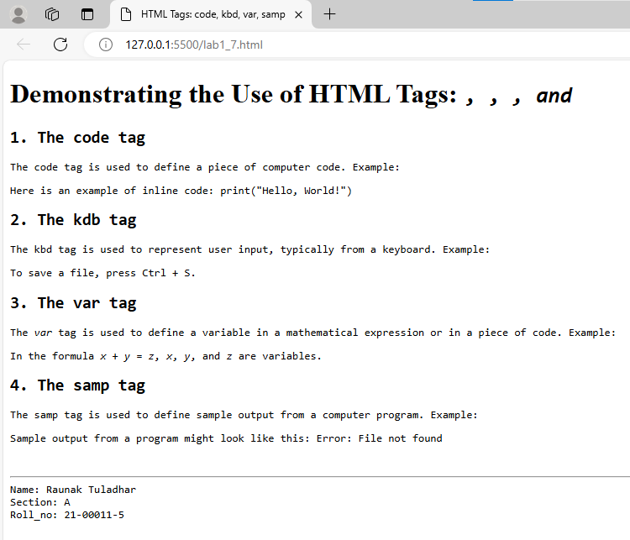

**8. Write HTML code to demonstrate:**

**a. Unordered list**

**b. Ordered list**

**c. Nested unordered list**

**d. Nested ordered list**

**e. Definition list**

<!DOCTYPE html>

<html lang="en">

<head>

<meta charset="UTF-8">

<meta name="viewport" content="width=device-width, initial-scale=1.0">

<title>List</title>

</head>

<body>

<h3>a. Unordered List</h3>

<ul>

<li>Fruits</li>

<li>Vegetables</li>

</ul>

<br>

<h3>b. Ordered List</h3>

<ol>

<li>Science</li>

<li>Maths</li>

</ol>

<br>

<h3>c. Nested Unordered List</h3>

<ul>

<li>Fruits</li>

<ul type="circle">

<li>Apple</li>

<li>Mango</li>

</ul>

<li>Vegetables</li>

<ul type="circle">

<li>Cauliflower</li>

<li>Brocolli</li>

</ul>

</ul>

<br>

<h3>d. Nested Ordered List</h3>

<ol>

<li>Science</li>

<ol type="i">

<li>Physics</li>

<li>Chemistry</li>

<li>Biology</li>

</ol>

<li>Maths</li>

<ol type="a">

<li>Arithmetic</li>

<li>Geometry</li>

<li>Algebra</li>

</ol>

</ol>

<br>

<h3>e. Definition List</h3>

<dl>

<dt>HTML</dt>

<dd>Hyper Text Markup Language</dd>

</dl>

<br>

<hr>

<footer>

Name: Raunak Tuladhar <br>

Section: A <br>

Roll_no: 21-00011-5

</footer>

</body>

</html>

**Output:**

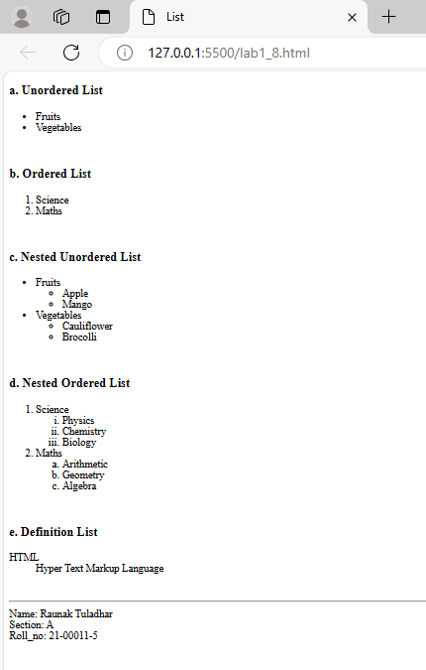

1. **Write HTML code to demonstrate an image as a list.**

<!DOCTYPE html>

<html lang="en">

<head>

<meta charset="UTF-8">

<meta name="viewport" content="width=device-width, initial-scale=1.0">

<title>Images as List Items</title>

</head>

<body>

<h1>Image List</h1>

<p>Below is a list of images displayed as list items:</p>

<ul>

<li>

<img src="img/everest.jpg" alt="Mountain" height="100px">

Mount Everest, the highest peak in the world.

</li>

<li>

<img src="img/swoyambhu.jpg" alt="swoyambhu" height="100px">

Swoyambhunath Stupa, a holy place.

</li>

<li>

<img src="img/phewa.jpg" alt="Lake" height="100px" width="200px">

Phewa Lake, situated in Pokhara.

</li>

</ul>

<br>

<hr>

<footer>

Name: Raunak Tuladhar <br>

Section: A <br>

Roll_no: 21-00011-5

</footer>

</body>

</html>

**Output:**

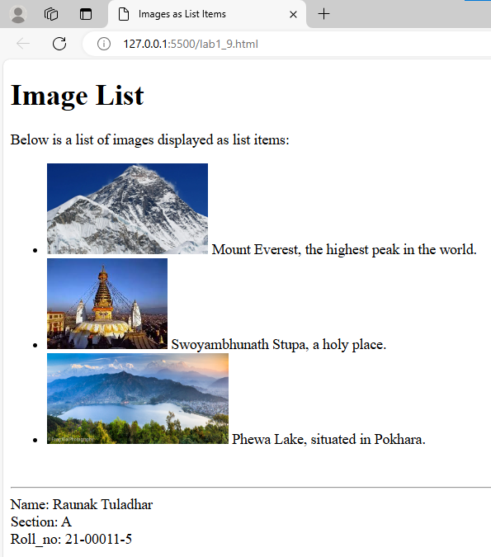

1. **Write HTML code to demonstrate the use of URLs along with absolute and relative URLs.**

<!DOCTYPE html>

<html lang="en">

<head>

<meta charset="UTF-8">

<meta name="viewport" content="width=device-width, initial-scale=1.0">

<title>Absolute and relative URL</title>

</head>

<body>

<h2>Absolute and Relative URLs</h2>

<h3>Absolute URL</h3>

<p><a href="https://www.google.com">Google</a></p>

<h3>Relative URL</h3>

<p><a href="img/everest.jpg">View Image</a></p>

<p><a href="about.html">About Page</a></p>

<br>

<hr>

<footer>

Name: Raunak Tuladhar <br>

Section: A <br>

Roll_no: 21-00011-5

</footer>

</body>

</html>

**Output:**

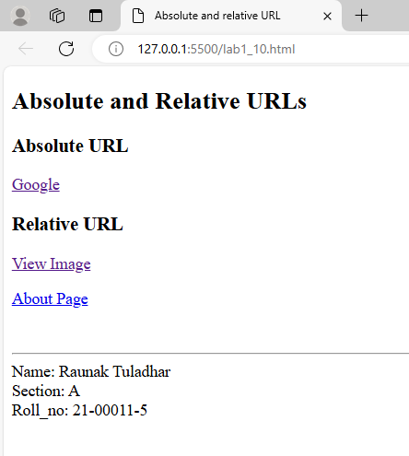

1. **How can you create a link in HTML? Show a proper section of the code.**

<!DOCTYPE html>

<html lang="en">

<head>

<meta charset="UTF-8">

<meta name="viewport" content="width=device-width, initial-scale=1.0">

<title>Creating a link in HTML</title>

</head>

<body>

<h2>Creation of Link</h2>

<p>To Visit Youtube, click <a href="https://www.youtube.com">Here</a></p>

<br>

<hr>

<footer>

Name: Raunak Tuladhar <br>

Section: A <br>

Roll_no: 21-00011-5

</footer>

</body>

</html>

**Output:**

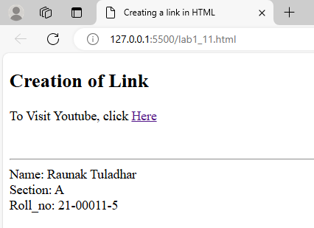

1. **Write HTML code to generate the output with the use of anchor tags: Home About Gallery Home is in parent directory, About is in sub directory of Home and Gallery is in root directory. Write the code for each and every tabs.**

**Home Page:**

<!DOCTYPE html>

<html lang="en">

<head>

    <meta charset="UTF-8">

    <meta name="viewport" content="width=device-width, initial-scale=1.0">

    <title>Anchor tags</title>

</head>

<body>

    <h2>Home</h2>

    <p>This is Home Page.</p>

    <p>

        <a href="#">Home</a>

        <a href="about/about.html">About</a>

        <a href="gallery.html">Gallery</a>

    </p>

    <br>

    <hr>

    <footer>

        Name: Raunak Tuladhar <br>

        Section: A <br>

        Roll_no: 21-00011-5

    </footer>

</body>

</html>

**About Page:**

<!DOCTYPE html>

<html lang="en">

<head>

    <meta charset="UTF-8">

    <meta name="viewport" content="width=device-width, initial-scale=1.0">

    <title>About</title>

</head>

<body>

    <h2>About</h2>

    <p>This is About Page.</p>

    <p>

        <a href="../home.html">Home</a>

        <a href="#">About</a>

        <a href="../gallery.html">Gallery</a>

    </p>

    <br>

    <hr>

    <footer>

        Name: Raunak Tuladhar <br>

        Section: A <br>

        Roll_no: 21-00011-5

    </footer>

</body>

</html>

**Gallery Page:**

<!DOCTYPE html>

<html lang="en">

<head>

    <meta charset="UTF-8">

    <meta name="viewport" content="width=device-width, initial-scale=1.0">

    <title>Gallery</title>

</head>

<body>

    <h2>Gallery</h2>

    <p>This is Gallery Page.</p>

    <p>

        <a href="home.html">Home</a>

        <a href="about/about.html">About</a>

        <a href="#">Gallery</a>

    </p>

    <br>

    <hr>

    <footer>

        Name: Raunak Tuladhar <br>

        Section: A <br>

        Roll_no: 21-00011-5

    </footer>

</body>

</html>

**Output:**

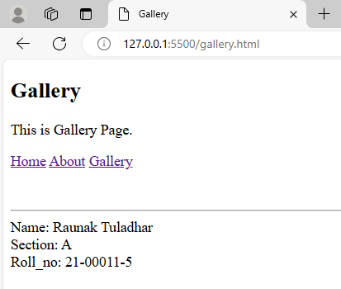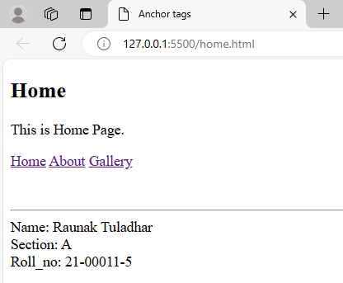

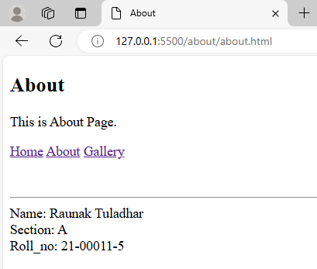

1. **Create an image gallery of any three popular places in Nepal along with their short description with the images aligned in left or right.**

<!DOCTYPE html>

<html lang="en">

<head>

    <meta charset="UTF-8">

    <meta name="viewport" content="width=device-width, initial-scale=1.0">

    <title>Popular places in Nepal</title>

</head>

<body>

    <h2>Mount Everest</h2><br>

    <img src="img/everest.jpg" alt="Mt.Everest" height="100px" align="left">

    <p>Mount Everest is the highest peak in the world. It is 8848m tall. It is located in the Himalayas and is a popular destination for mountaineers and adventurers from around the globe.</p>

    <br clear="all"><br><br>

    <h2>Swoyambhunath Temple</h2>

    <img src="img/swoyambhu.jpg" alt="Swoyambhunath" height="100px" align="right">

    <p>Find peace and prayers on the little hillock of Swaymbhunath in the northwest of Kathmandu Valley. Visitors for whom the name was a tongue twister have called it "Monkey Temple" from the 1970s.</p>

    <br clear="all">

    <h2>Phewa Lake</h2>

    <img src="img/phewa.jpg" alt="Phewa Lake" height="100px" width="290px" align="left">

    <p>Phewa Lake or Phewa Tal is a freshwater lake in Nepal formerly called Baidam Tal located in the south of the Pokhara Valley that includes Pokhara city and parts of Sarangkot and Kaskikot. It is the second largest lake in Nepal and the largest in Gandaki Province after the Rara lake in comparison to Nepal's water bodies.</p>

    <br clear="all"><br>

    <hr>

    <footer>

        Raunak Tuladhar <br>

        Section: A <br>

        Roll_no: 21-00011-5

    </footer>

</body>

</html>

**Output:**

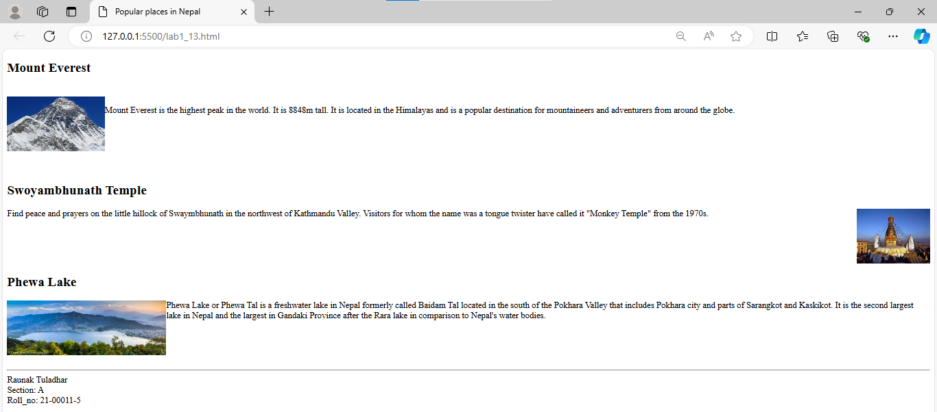

1. **Demonstrate the use of align, vspace and hspace attribute using minimum of six images. (Make a gallery).**

<!DOCTYPE html>

<html lang="en">

<head>

<meta charset="UTF-8">

<meta name="viewport" content="width=device-width, initial-scale=1.0">

<title>vspace and hspace</title>

</head>

<body>

<h1>Gallery</h1>

<table border="0" cellpadding="10">

<tr>

<td>

<img src="img/flower.jpg" alt="Flower" width="200" align="left" vspace="10" hspace="10">

</td>

<td>

<img src="img/parrot.jpg" alt="Parrot" width="200" align="left" vspace="10" hspace="10">

</td>

<td>

<img src="img/water.jpg" alt="Water" width="200" align="left" vspace="10" hspace="10">

</td>

</tr>

<tr>

<td>

<img src="img/zlatan.jpg" alt="Ibra" width="200" align="right" vspace="10" hspace="10">

</td>

<td>

<img src="img/swoyambhu.jpg" alt="swoyambhu" width="200" align="right" vspace="10" hspace="10">

</td>

<td>

<img src="img/everest.jpg" alt="Mountain" width="200" align="right" vspace="10" hspace="10">

</td>

</tr>

</table>

<br>

<hr>

<footer>

Name: Raunak Tuladhar <br>

Section: A <br>

Roll_no: 21-00011-5

</footer>

</body>

</html>

**Output:**

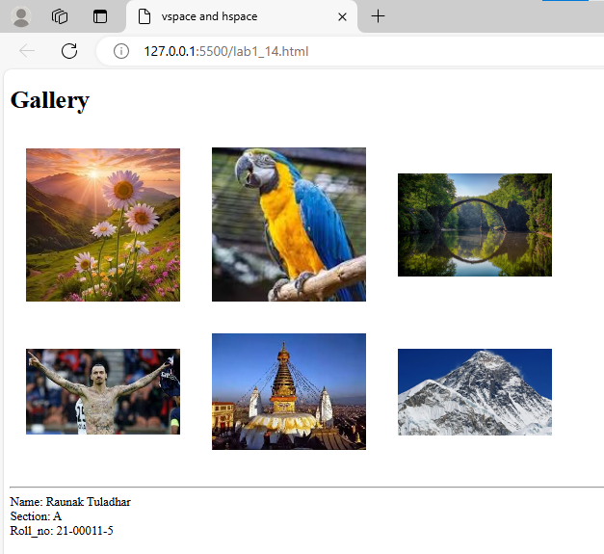

1. **Create a web page that demonstrates the use of destination anchors using name and id attributes.**

<!DOCTYPE html>

<html lang="en">

<head>

    <meta charset="UTF-8">

    <meta name="viewport" content="width=device-width, initial-scale=1.0">

    <title>Destination Anchors</title>

</head>

<body>

    <h1>Demonstrating Destination Anchors</h1>

    <p><a href="#section1">Go to Section 1</a></p>

    <p><a href="#section2">Go to Section 2</a></p>

    <p><a href="#section3">Go to Section 3</a></p>

    <hr>

    <h2 id="section1" name="section1">Section 1</h2>

    <p>This is the content of Section 1. You can navigate back to the <a href="#top">top of the page</a> or to other sections

    using the links above.</p>

    <h2 id="section2" name="section2">Section 2</h2>

    <p>This is the content of Section 2. You can navigate back to the <a href="#top">top of the page</a> or to other sections

    using the links above.</p>

    <h2 id="section3" name="section3">Section 3</h2>

    <p>This is the content of Section 3. You can navigate back to the <a href="#top">top of the page</a> or to other sections

    using the links above.</p>

    <p id="top">Back to the top of the page.</p>

    <br>

    <hr>

    <footer>

        Name: Raunak Tuladhar <br>

        Section: A <br>

        Roll_no: 21-00011-5

    </footer>

</body>

</html>

**Output:**

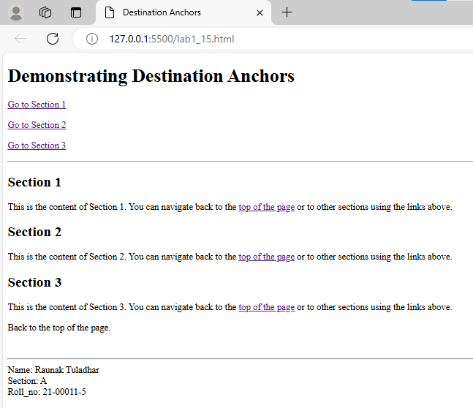

1. **Create a webpage to containing brief description about your college and links to your college and university website.**

<!DOCTYPE html>

<html lang="en">

<head>

<meta charset="UTF-8">

<meta name="viewport" content="width=device-width, initial-scale=1.0">

<title>College and University Information</title>

</head>

<body>

<h1>About My College</h1>

<p>Prime College is an educational institution striving to deliver practical-based education, empowering young minds and

cultivating a culture of excellence among skilled individuals. We offer diverse academic programs at both undergraduate and

graduate levels. Our dedicated faculty members bring their extensive expertise to the classroom, fostering a dynamic learning

environment.

</p>

<p>For more information about our college, please visit our <a href="http://www.prime.edu.np" target="blank">college

website</a>.

</p>

<p>Our college is affiliated with Tribhuvan University. For details about the university and its programs, visit the <a

href="http://www.tu.edu.np" target="_blank">Tribhuvan University website</a>.

</p>

<br>

<hr>

<footer>

Name: Raunak Tuladhar <br>

Section: A <br>

Roll_no: 21-00011-5

</footer>

</body>

</html>

**Output:**

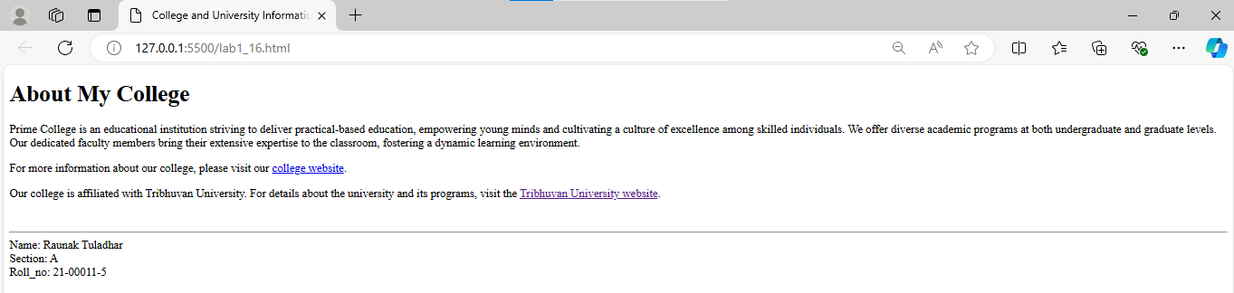

1. **Demonstrate the use of top to bottom and bottom to top link using anchor tags.**

<!DOCTYPE html>

<html lang="en">

<head>

<meta charset="UTF-8">

<meta name="viewport" content="width=device-width, initial-scale=1.0">

<title>Top to Bottom and Bottom to Top Links</title>

</head>

<body>

<h1>Demonstrating Top to Bottom and Bottom to Top Links</h1>

<p><a href="#bottom">Go to Bottom of the Page</a></p>

<p><a href="#top">Go to Top of the Page</a></p>

<hr>

<h2 id="top">Top of the Page</h2>

<p>This is the top of the page. You can navigate to the bottom of the page using the link above.</p>

<hr>

<h2 id="section1">Section 1</h2>

<p>This is Section 1. Continue to the bottom of the page.</p>

<h2 id="section2">Section 2</h2>

<p>This is Section 2. Continue to the bottom of the page.</p>

<h2 id="section3">Section 3</h2>

<p>This is Section 3. Continue to the bottom of the page.</p>

<hr>

<h2 id="bottom">Bottom of the Page</h2>

<p>This is the bottom of the page. You can navigate back to the top using the link above.</p>

<br>

<hr>

<footer>

Name: Raunak Tuladhar <br>

Section: A <br>

Roll_no: 21-00011-5

</footer>

</body>

</html>

**Output:**

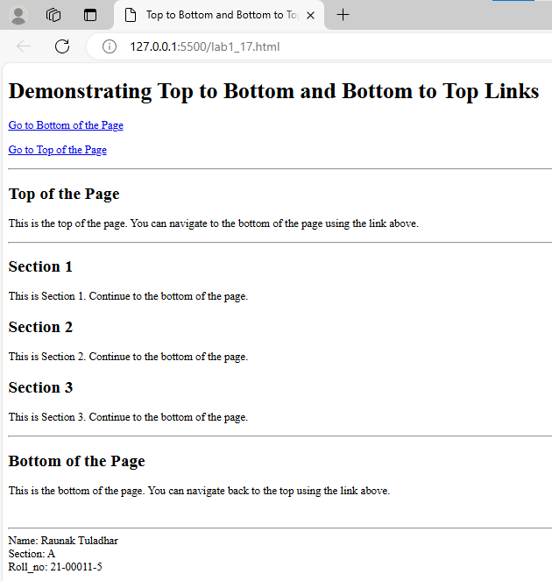

1. **Write HTML code to add image using img tag.**

<!DOCTYPE html>

<html lang="en">

<head>

<meta charset="UTF-8">

<meta name="viewport" content="width=device-width, initial-scale=1.0">

<title>Adding an Image</title>

</head>

<body>

<h1>Add Image</h1>

<img src="img/water.jpg" alt="Beautiful Nature" height="300px">

<br>

<hr>

<footer>

Name: Raunak Tuladhar <br>

Section: A <br>

Roll_no: 21-00011-5

</footer>

</body>

</html>

**Output:**

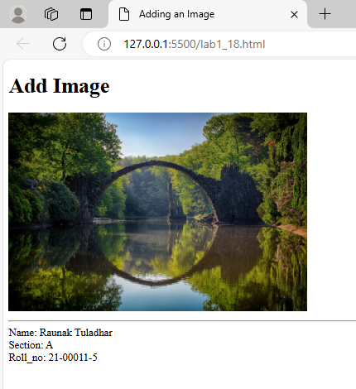

1. **Write HTML code to create an image gallery of 9 images with 3 images in a row each having 200 width and height 250.**

<!DOCTYPE html>

<html lang="en">

<head>

<meta charset="UTF-8">

<meta name="viewport" content="width=device-width, initial-scale=1.0">

<title>Image Gallery of 9 Images</title>

</head>

<body>

<h1>Image Gallery</h1>

<table border="0" cellpadding="10">

<tr>

<td><img src="img/9000.png" alt="Image 1" width="200" height="100"></td>

<td><img src="img/everest.jpg" alt="Image 2" width="200" height="100"></td>

<td><img src="img/flower.jpg" alt="Image 3" width="200" height="100"></td>

</tr>

<tr>

<td><img src="img/phewa.jpg" alt="Image 4" width="200" height="100"></td>

<td><img src="img/gogeta.jpg" alt="Image 5" width="200" height="100"></td>

<td><img src="img/zlatan.jpg" alt="Image 6" width="200" height="100"></td>

</tr>

<tr>

<td><img src="img/3.jpg" alt="Image 7" width="200" height="100"></td>

<td><img src="img/parrot.jpg" alt="Image 8" width="200" height="100"></td>

<td><img src="img/swoyambhu.jpg" alt="Image 9" width="200" height="100"></td>

</tr>

</table>

<br>

<hr>

<footer>

Name: Raunak Tuladhar <br>

Section: A <br>

Roll_no.: 21-00011-5

</footer>

</body>

</html>

**Output:**

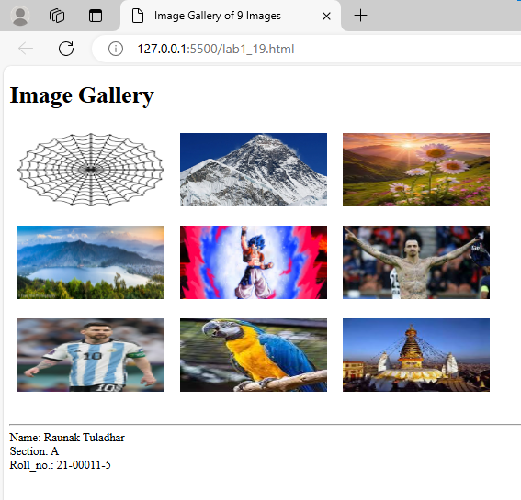

1. **Write a HTML code to map image as Client side and Server Side.**

**Client Side:**

<!DOCTYPE html>

<html lang="en">

<head>

    <meta charset="UTF-8">

    <meta name="viewport" content="width=device-width, initial-scale=1.0">

    <title>Client Side</title>

</head>

<body>

    <h1>Client-Side Image Map</h1>

    <img src="img/flower.jpg" alt="Map Image" usemap="#image-map" width="500" height="300">

    <map name="image-map">

    <area shape="rect" coords="34,44,270,350" href="http://www.google.com" alt="Example Link">

    <area shape="circle" coords="450,150,50" href="http://www.google.com" alt="Another Link">

    <area shape="poly" coords="150,50,200,100,250,50" href="http://www.google.com" alt="Polygon Link">

    </map>

    <br>

    <hr>

    <footer>

        Name: Raunak Tuladhar <br>

        Section: A <br>

        Roll_no: 21-00011-5

    </footer>

</body>

</html>

**Output:**

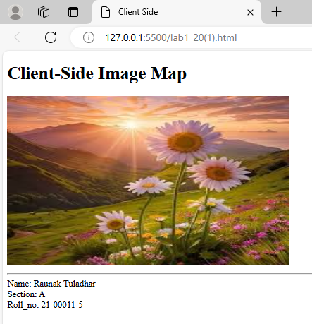

**Server Side:**

<!DOCTYPE html>

<html lang="en">

<head>

    <meta charset="UTF-8">

    <meta name="viewport" content="width=device-width, initial-scale=1.0">

    <title>Server Side Image Map</title>

</head>

<body>

    <h1>Server-Side Image Map</h1>

    <form action="server_side_script.php" method="post">

    <img src="img/parrot.jpg" alt="Map Image" usemap="#image-map" width="500" height="300">

    <map name="image-map">

    <area shape="rect" coords="34,44,270,350" href="server_side_script.php?area=example" alt="Example Link">

    <area shape="circle" coords="450,150,50" href="server_side_script.php?area=another" alt="Another Link">

    <area shape="poly" coords="150,50,200,100,250,50" href="server_side_script.php?area=polygon" alt="Polygon Link">

    </map>

    </form>

    <br>

    <hr>

    <footer>

        Name: Raunak Tuladhar <br>

        Section: A <br>

        Roll_no: 21-00011-5

    </footer>

</body>

</html>

**Output:**

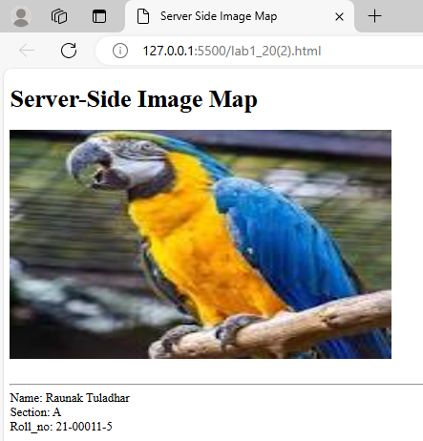

1. **Write a HTML code to demonstrate how audio, video can be added to the web pages along with all the attributes.**

<!DOCTYPE html>

<html lang="en">

<head>

<meta charset="UTF-8">

<meta name="viewport" content="width=device-width, initial-scale=1.0">

<title>Audio and Video</title>

</head>

<body>

<h1>Adding Audio and Video to Web Pages</h1>

<h2>Audio Example</h2>

<audio controls autoplay loop preload="auto">

<source src="audio_and_video/1.mp3" type="audio/mp3">

Your browser does not support the audio element.

</audio>

<h2>Video Example</h2>

<video width="640" height="360" controls>

<source src="audio_and_video/7.mp4" type="video/mp4">

Your browser does not support the video element.

</video>

<br>

<hr>

<footer>

Name: Raunak Tuladhar <br>

Section: A <br>

Roll_no: 21-00011-5

</footer>

</body>

</html>

**Output:**

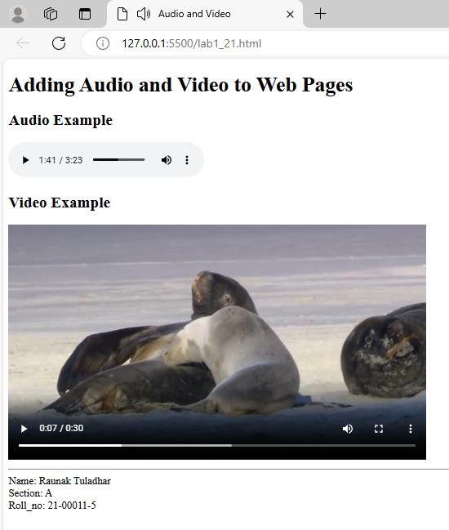

1. **Write the HTML code to print the following output:**

|  |  |  |  |  |  |  |
| --- | --- | --- | --- | --- | --- | --- |
| **SN** | **Name** |  | **College** | **Address** | **Email** | **Phone** |
|  | **First Name** | **Last Name** |  |  |  |  |
|  |  |  |  |  |  |  |
|  |  |  |  |  |  |  |
|  |  |  |  |  |  |  |

**Fill at least 5 details.**

<!DOCTYPE html>

<html lang="en">

<head>

    <meta charset="UTF-8">

    <meta name="viewport" content="width=device-width, initial-scale=1.0">

    <title>Table</title>

</head>

<body>

    <h2>Student Information</h2>

    <table border="1" cellpadding="3" cellspacing="0">

        <tr>

            <th rowspan="2">S.N.</th>

            <th colspan="2">Name</th>

            <th rowspan="2">College</th>

            <th rowspan="2">Address</th>

            <th rowspan="2">Email</th>

            <th rowspan="2">Phone</th>

        </tr>

        <tr>

            <th>First Name</th>

            <th>Last Name</th>

        </tr>

        <tr>

            <td>1</td>

            <td>Ronik</td>

            <td>Maharjan</td>

            <td>Prime</td>

            <td>Ratnapark</td>

            <td>ronk@gmail.com</td>

            <td>9845656687</td>

        </tr>

        <tr>

            <td>2</td>

            <td>Cristian</td>

            <td>Haugan</td>

            <td>Oxford</td>

            <td>Thamel</td>

            <td>crha@gmail.com</td>

            <td>98056234545</td>

        </tr>

        <tr>

            <td>3</td>

            <td>Ram</td>

            <td>Bharat</td>

            <td>KMC</td>

            <td>New Baneshwor</td>

            <td>ram@gmail.com</td>

            <td>9871565548</td>

        </tr>

        <tr>

            <td>4</td>

            <td>Shyam</td>

            <td>Bastakoti</td>

            <td>ASCOL</td>

            <td>Kupondole</td>

            <td>shyambast@gmail.com</td>

            <td>9861585874</td>

        </tr>

        <tr>

            <td>5</td>

            <td>Sundri</td>

            <td>Shrestha</td>

            <td>Padma Kanya</td>

            <td>New Road</td>

            <td>sunshres@gmail.com</td>

            <td>9851454462</td>

        </tr>

    </table>

    <br>

    <hr>

    <footer>

        Name: Raunak Tuladhar <br>

        Section: A <br>

        Roll_no: 21-00011-5

    </footer>

</body>

</html>

**Output:**

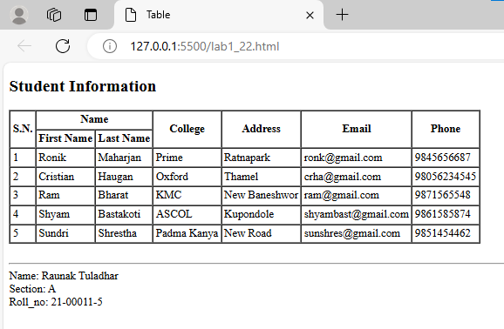

1. **Write HTML code to create a webpage with a list of contents using HTML tables.**

<!DOCTYPE html>

<html lang="en">

<head>

<meta charset="UTF-8">

<meta name="viewport" content="width=device-width, initial-scale=1.0">

<title>List of Content</title>

</head>

<body>

<h1>List of Contents</h1>

<table border="1" cellpadding="5" cellspacing="0">

<tr>

<th>Chapter</th>

<th>Title</th>

<th>Page Number</th>

</tr>

<tr>

<td>1</td>

<td>Introduction</td>

<td>1</td>

</tr>

<tr>

<td>2</td>

<td>Getting Started</td>

<td>5</td>

</tr>

<tr>

<td>3</td>

<td>HTML Basics</td>

<td>12</td>

</tr>

<tr>

<td>4</td>

<td>CSS Fundamentals</td>

<td>25</td>

</tr>

<tr>

<td>5</td>

<td>JavaScript Introduction</td>

<td>40</td>

</tr>

</table>

<br>

<hr>

<footer>

Name: Raunak Tuladhar <br>

Section: A <br>

Roll_no: 21-00011-5

</footer>

</body>

</html>

**Output:**

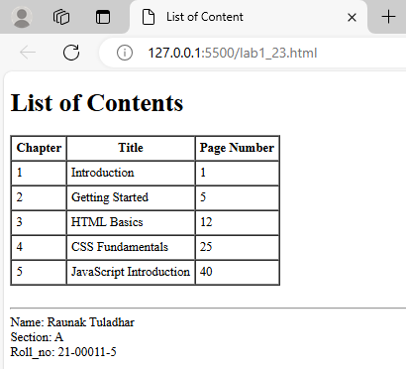

**24. Design the following single table using HTML.**

|  |  |  |  |  |  |
| --- | --- | --- | --- | --- | --- |
| **A** | **B** | | **C** | | **D** |
| **E** | | | | | **F** |
| **G** |
| **F** | | **J** | | | **K** |
| **L** | | | | **M** | |

<!DOCTYPE html>

<html lang="en">

<head>

    <meta charset="UTF-8">

    <meta name="viewport" content="width=device-width, initial-scale=1.0">

    <title>Table Design</title>

</head>

<body>

    <table border="1" cellpadding="5" cellspacing="0" width="600" height="300">

        <tr>

            <td>A</td>

            <td colspan="2" width="30">B</td>

            <td>C</td>

            <td>D</td>

        </tr>

        <tr>

            <td colspan="4" rowspan="2">E</td>

            <td>F</td>

        </tr>

        <tr>

            <td>G</td>

        </tr>

        <tr>

            <td colspan="2">H</td>

            <td colspan="2">J</td>

            <td>K</td>

        </tr>

        <tr>

            <td colspan="3">L</td>

            <td colspan="2">M</td>

        </tr>

    </table>

    <br>

    <hr>

    <footer>

        Name: Raunak Tuladhar <br>

        Section: A <br>

        Roll_no: 21-00011-5

    </footer>

</body>

</html>

**Output:**

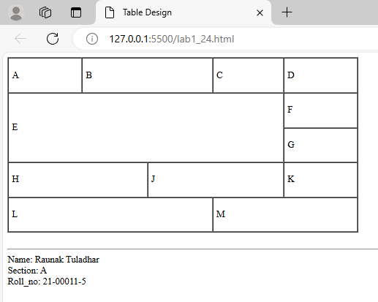

1. **Design the following table using nested tables in HTML.**

|  |  |  |
| --- | --- | --- |
| **Logo** | **ABC Company** | |
| |  | | --- | | **Home(link)** | | **About Us(link)** | | **Contact Us(link)** | | |  |  | | --- | --- | | **Content 1** | **News 1** | | **Content 2** | **News 2** | | |
| **Copyright** | **Facebook, Twitter(link)** | **Powered By** |

<!DOCTYPE html>

<html lang="en">

<head>

    <meta charset="UTF-8">

    <meta name="viewport" content="width=device-width, initial-scale=1.0">

    <title>Nested Table</title>

</head>

<body>

    <table border="1" cellpadding="5" cellspacing="0" width="600">

        <tr>

            <td>Logo <img src="Images/image1.jpeg" width="50px" height="auto"> </td>

            <td colspan="2">ABC Company</td>

        </tr>

        <tr>

            <td>

                <table border="1" cellpadding="5" cellspacing="0" width="100%">

        <tr>

            <td><a href="#">Home</a></td>

        </tr>

        <tr>

            <td><a href="#">About</a></td>

        </tr>

        <tr>

            <td><a href="#">Contact</a></td>

        </tr>

                </table>

            </td>

            <td colspan="2">

                <table border="1" cellpadding="5" cellspacing="0" width="100%">

        <tr>

            <td>Content 1</td>

            <td>News 1</td>

        </tr>

        <tr>

            <td>Content 2</td>

            <td>News 2</td>

        </tr>

                </table>

            </td>

        </tr>

        <tr>

            <td>Copyright</td>

            <td><a href="#">Facebook,</a><a href="#">Twitter</a></td>

            <td>Powered By</td>

        </tr>

    </table>

    <br>

    <hr>

    <footer>

        Name: Raunak Tuladhar <br>

        Section: A <br>

        Roll_no: 21-00011-5

    </footer>

</body>

</html>

**Output:**

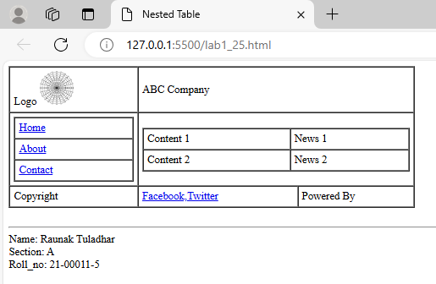

1. **Design an html form to demonstrate the 10 different types of controls generated using INPUT tag. The form should contain text boxes, radio buttons, checkboxes, submit buttons, reset buttons, and hidden controls.**

<!DOCTYPE html>

<html lang="en">

<head>

<meta charset="UTF-8">

<meta name="viewport" content="width=device-width, initial-scale=1.0">

<title>Form</title>

</head>

<body>

<h1>HTML Form</h1>

<form action="#" method="post">

<label for="name">Name:</label>

<input type="text" id="name" name="name"><br><br>

<label for="password">Password:</label>

<input type="password" id="password" name="password"><br><br>

<label>Gender:</label>

<input type="radio" id="male" name="gender" value="male">

<label for="male">Male</label>

<input type="radio" id="female" name="gender" value="female">

<label for="female">Female</label><br><br>

<label for="hobbies">Hobbies:</label><br>

<input type="checkbox" id="reading" name="hobbies" value="reading">

<label for="reading">Reading</label><br>

<input type="checkbox" id="traveling" name="hobbies" value="traveling">

<label for="traveling">Traveling</label><br>

<input type="checkbox" id="gaming" name="hobbies" value="gaming">

<label for="gaming">Gaming</label><br><br>

<label for="email">Email:</label>

<input type="email" id="email" name="email"><br><br>

<label for="age">Age:</label>

<input type="number" id="age" name="age" min="1" max="100"><br><br>

<label for="dob">Date of Birth:</label>

<input type="date" id="dob" name="dob"><br><br>

<label for="website">Website:</label>

<input type="url" id="website" name="website"><br><br>

<label for="resume">Upload Resume:</label>

<input type="file" id="resume" name="resume"><br><br>

<input type="hidden" name="user_id" value="12345">

<input type="submit" value="Submit">

<input type="reset" value="Reset">

</form>

<br>

<hr>

<footer>

Name: Raunak Tuladhar <br>

Section: A <br>

Roll_no: 21-00011-5

</footer>

</body>

</html>

**Output:**

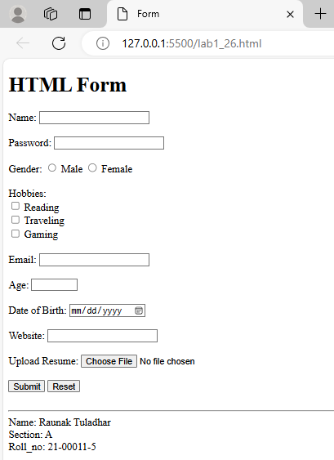

1. **Design an html form to submit a job application form. Demonstrate the use of drop-down list, text areas and file upload control.**

<!DOCTYPE html>

<html lang="en">

<head>

<meta charset="UTF-8">

<meta name="viewport" content="width=device-width, initial-scale=1.0">

<title>Job Application Form</title>

</head>

<body>

<h1>Job Application Form</h1>

<form action="submit_application.php" method="post" enctype="multipart/form-data">

<label for="full_name">Full Name:</label>

<input type="text" id="full_name" name="full_name" required><br><br>

<label for="email">Email:</label>

<input type="email" id="email" name="email" required><br><br>

<label for="phone">Phone Number:</label>

<input type="tel" id="phone" name="phone" required><br><br>

<label for="position">Position Applying For:</label>

<select id="position" name="position" required>

<option value="">--Select Position--</option>

<option value="software_engineer">Software Engineer</option>

<option value="web_developer">Web Developer</option>

<option value="project_manager">Project Manager</option>

<option value="designer">Designer</option>

</select><br><br>

<label for="experience">Years of Experience:</label>

<select id="experience" name="experience" required>

<option value="">--Select Experience--</option>

<option value="0-1">0-1 years</option>

<option value="1-3">1-3 years</option>

<option value="3-5">3-5 years</option>

<option value="5+">5+ years</option>

</select><br><br>

<label for="cover_letter">Cover Letter:</label><br>

<textarea id="cover_letter" name="cover_letter" rows="5" cols="40" required></textarea><br><br>

<label for="resume">Upload Resume:</label>

<input type="file" id="resume" name="resume" required><br><br>

<input type="submit" value="Submit Application">

<input type="reset" value="Reset Form">

</form>

<br>

<hr>

<footer>

Name: Raunak Tuladhar <br>

Section: A <br>

Roll_no: 21-00011-5

</footer>

</body>

</html>

**Output:**

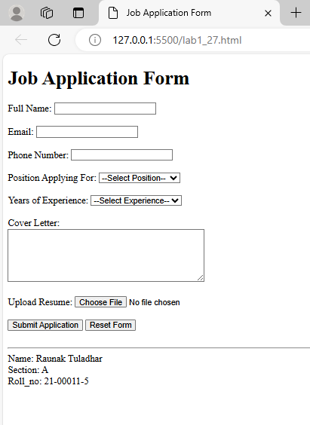

1. **Demonstrate HTML5 tags (like article, aside, figure, section).**

<!DOCTYPE html>

<html lang="en">

<head>

<meta charset="UTF-8">

<meta name="viewport" content="width=device-width, initial-scale=1.0">

<title>Demonstration of HTML5 Tags</title>

</head>

<body>

<h1>Understanding HTML5 Semantic Tags</h1>

<section>

<h2>Main Content</h2>

<article>

<h3>The Importance of Semantic Tags</h3>

<p>Semantic HTML5 tags provide meaning to the web content. These tags help search engines and other user devices

to determine the significance and context of web pages.</p>

<p>Using semantic tags, we make our web pages more accessible and improve SEO performance.</p>

</article>

<article>

<h3>Key HTML5 Tags</h3>

<p>The following are some of the key HTML5 semantic tags:</p>

<ul>

<li><strong>&lt;article&gt;</strong>: Represents a self-contained piece of content.</li>

<li><strong>&lt;section&gt;</strong>: Defines a section within a document.</li>

<li><strong>&lt;aside&gt;</strong>: Represents content related to the main content, often used for sidebars.</li>

<li><strong>&lt;figure&gt;</strong>: Used for self-contained content, such as images or diagrams, along with their

captions.</li>

<li><strong>&lt;figcaption&gt;</strong>: Provides a caption for the content inside a &lt;figure&gt; tag.</li>

</ul>

</article>

</section>

<aside>

<h2>Sidebar</h2>

<p>This is an aside section where related content, such as links to related articles or advertisements, might appear.</p>

</aside>

<section>

<h2>Example of Figure with Caption</h2>

<figure>

<img src="img/flower.jpg" alt="Beautiful Landscape" width="100">

<figcaption>A beautiful view.</figcaption>

</figure>

</section>

<br>

<hr>

<footer>

Name: Raunak Tuladhar <br>

Section: A <br>

Roll_no: 21-00011-5

</footer>

</body>

</html>

**Output:**

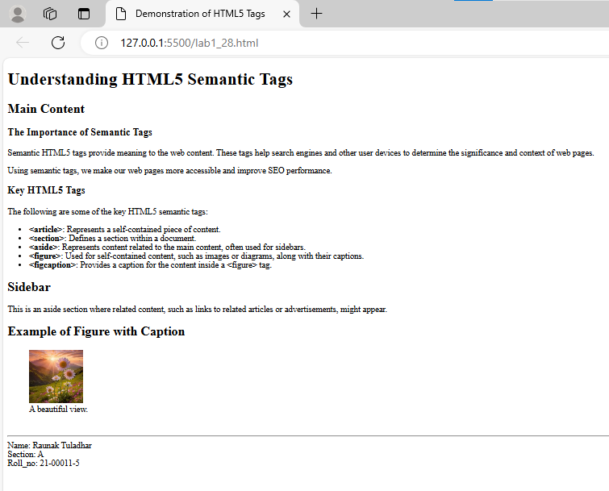

1. **Demonstrate the use of the HTML5 datetime input type.**

<!DOCTYPE html>

<html lang="en">

<head>

<meta charset="UTF-8">

<meta name="viewport" content="width=device-width, initial-scale=1.0">

<title>HTML5 datetime input type</title>

</head>

<body>

<h1>Event Scheduling Form</h1>

<form action="#" method="post">

<label for="event_name">Event Name:</label>

<input type="text" id="event_name" name="event_name" required><br><br>

<label for="event_datetime">Event Date and Time:</label>

<input type="datetime-local" id="event_datetime" name="event_datetime" required><br><br>

<input type="submit" value="Schedule Event">

<input type="reset" value="Reset Form">

</form>

<hr>

<br>

<footer>

Name: Raunak Tuladhar <br>

Section: A <br>

Roll_no: 21-00011-5

</footer>

</body>

</html>

**Output:**

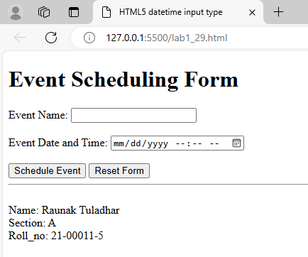

1. **Demonstrate the use of HTML5 range input type.**

<!DOCTYPE html>

<html lang="en">

<head>

<meta charset="UTF-8">

<meta name="viewport" content="width=device-width, initial-scale=1.0">

<title>HTML5 range input type</title>

</head>

<body>

<h3>Volume Control</h3>

<form action="#" method="post">

<label for="volume">Set Volume Level:</label>

<input type="range" id="volume" name="volume" min="0" max="100" value="50" oninput="this.nextElementSibling.value = this.value">

<output>50</output><br><br>

<input type="submit" value="Submit Volume">

</form>

<br>

<hr>

<footer>

Name: Raunak Tuladhar <br>

Section: A <br>

Roll_no: 21-00011-5

</footer>

</body>

</html>

**Output:**

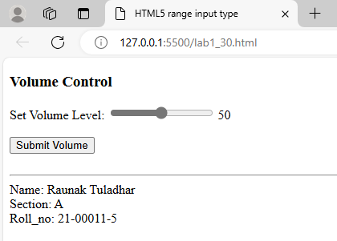

**Lab 2: CSS**

1. **Illustrate the use of background properties in CSS (for image).**

<!DOCTYPE html>

<html lang="en">

<head>

<meta charset="UTF-8">

<meta name="viewport" content="width=device-width, initial-scale=1.0">

<title>Background properties in CSS</title>

<style>

.bg{

width: 100%;

height: 500px;

background-image: url('../img/everest.jpg');

background-size: cover;

background-position: center;

background-repeat: no-repeat;

background-attachment: fixed;

}

</style>

</head>

<body>

<div class="bg">

Highest peak in the world.

</div>

<br>

<hr>

<footer>

Name: Raunak Tuladhar <br>

Section: A <br>

Roll_no: 21-00011-5

</footer>

</body>

</html>

**Output:**

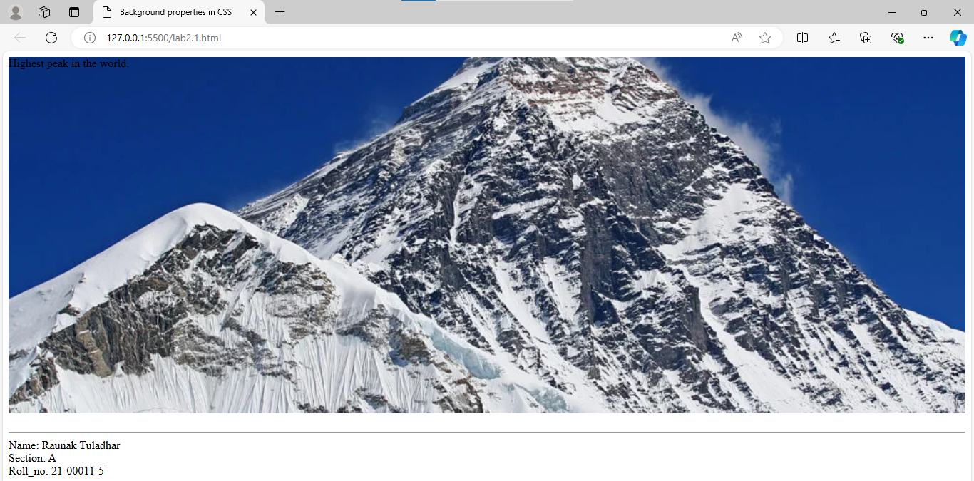

1. **Construct a web page with four paragraph and style using CSS.**

<!DOCTYPE html>

<html lang="en">

<head>

<meta charset="UTF-8">

<meta name="viewport" content="width=device-width, initial-scale=1.0">

<title>Paragraph and style</title>

<style>

p {

font-family: Arial, sans-serif;

margin: 20px;

background-color: #000000;

color: #fff;

margin-bottom: 10px;

}

.bold {

font-weight: bold;

}

.italic {

font-style: italic;

}

.center {

text-align: center;

}

.underline {

text-decoration: underline;

}

</style>

</head>

<body>

<div>

<p class="bold">This is the first paragraph. It is bold.</p>

<p class="italic">This is the second paragraph. It is italicized.</p>

<p class="center">This is the third paragraph. It is centered.</p>

<p class="underline">This is the fourth paragraph. It is underlined.</p>

</div>

<br>

<hr>

<footer>

Name: Raunak Tuladhar <br>

Section: A <br>

Roll_no: 21-00011-5

</footer>

</body>

</html>

**Output:**

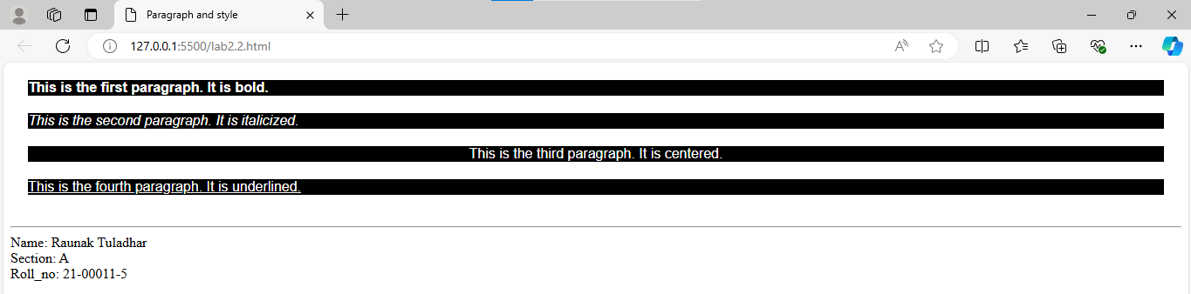

1. **Design a web page with six images and style them using external CSS.**

**HTML:**

<!DOCTYPE html>

<html lang="en">

<head>

<meta charset="UTF-8">

<meta name="viewport" content="width=device-width, initial-scale=1.0">

<title>Six Images</title>

<link rel="stylesheet" href="CSS_21-00011-5/lab2.3.css">

</head>

<body>

<div class="image-gallery">

<img src="../img/flower.jpg" alt="Flower">

<img src="../img/gogeta.jpg" alt="Gogeta">

<img src="../img/parrot.jpg" alt="Parrot">

<img src="../img/swoyambhu.jpg" alt="swoyambhu">

<img src="../img/water.jpg" alt="water">

<img src="../img/zlatan.jpg" alt="zlatan">

</div>

<br>

<hr>

<footer>

Name: Raunak Tuladhar <br>

Section: A <br>

Roll_no: 21-00011-5

</footer>

</body>

</html>

**CSS:**

.image-gallery {

    display: flex;

    flex-wrap: wrap;

    justify-content: space-around;

   }

   .image-gallery img {

    width: 150px;

    height: auto;

    margin: 10px;

    border: 2px solid #ddd;

    border-radius: 8px;

    box-shadow: 0 4px 8px rgba(0, 0, 0, 0.2);

   }

   .image-gallery img:hover {

    border-color: #333;

    box-shadow: 0 6px 12px rgba(0, 0, 0, 0.3);

   }

**Output:**

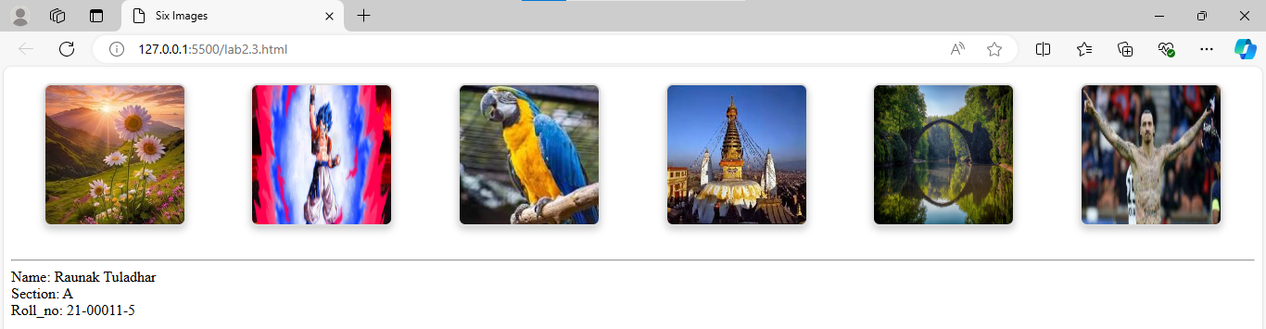

1. **Make a nested list using internal CSS.**

<!DOCTYPE html>

<html lang="en">

<head>

<meta charset="UTF-8">

<meta name="viewport" content="width=device-width, initial-scale=1.0">

<title>Nested List using internal CSS</title>

<style>

ul{

list-style-type: none;

padding-left: 0;

}

li{

background: #766f6f;

margin-bottom: 5px;

padding: 10px;

border-radius: 5px;

}

ul ul{

background: #560b0b;

padding-left: 20px;

}

ul ul li{

background: #b655e3;

margin-bottom: 3px;

padding: 8px;

border-radius: 3px;

}

</style>

</head>

<body>

<ul>

<li>Item 1

<ul>

<li>Subitem 1.1</li>

<li>Subitem 1.2

<ul>

<li>Sub

-subitem 1.2.1</li>

<li>Sub

-subitem 1.2.2</li>

</ul>

</li>

</ul>

</li>

<li>Item 2

<ul>

<li>Subitem 2.1</li>

<li>Subitem 2.2</li>

</ul>

</li>

<li>Item 3</li>

</ul>

<br>

<hr>

<footer>

Name: Raunak Tuladhar <br>

Section: A <br>

Roll_no: 21-00011-5

</footer>

</body>

</html>

**Output:**

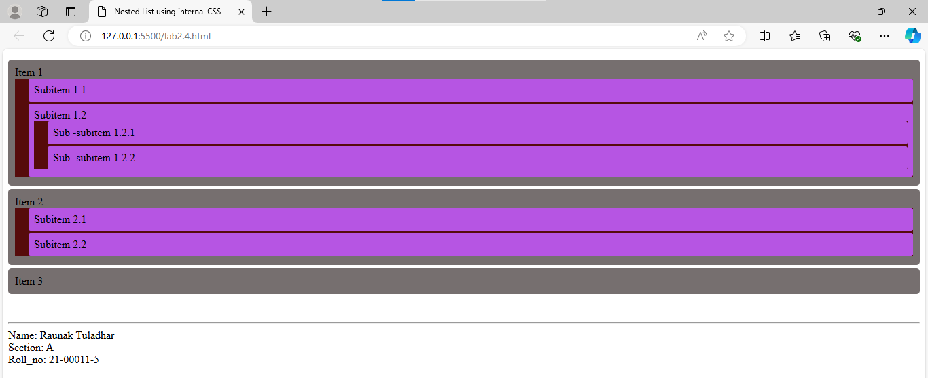

1. **Make a web page having 3 rows and 2 columns with all the hyperlinks and style it using external CSS.**

**HTML:**

<!DOCTYPE html>

<html lang="en">

<head>

<meta charset="UTF-8">

<meta name="viewport" content="width=device-width, initial-scale=1.0">

<title>Rows and Columns with hyperlinks</title>

<link rel="stylesheet" href="CSS_21-00011-5/lab2.5.css">

</head>

<body>

<div>

<div class="row">

<div class="column"><a href="#">Link 1</a></div>

<div class="column"><a href="#">Link 2</a></div>

</div>

<div class="row">

<div class="column"><a href="#">Link 3</a></div>

<div class="column"><a href="#">Link 4</a></div>

</div>

<div class="row">

<div class="column"><a href="#">Link 5</a></div>

<div class="column"><a href="#">Link 6</a></div>

</div>

</div>

<br>

<hr>

<footer>

Name: Raunak Tuladhar <br>

Section: A <br>

Roll_no: 21-00011-5

</footer>

</body>

</html>

**CSS:**

.row {

    overflow: hidden;

    margin-bottom: 10px;

   }

.column {

    float: left;

    width: 50%;

    box-sizing: border-box;

    padding: 10px;

}

.column a {

    text-decoration: none;

    color: #000;

    font-weight: bold;

    display: block;

    background: #fff;

    border: 5px solid #000000;

    padding: 20px;

    border-radius: 5px;

    text-align: center;

}

.column a:hover {

    color: #007bff;

    text-decoration: underline;

}

**Output:**

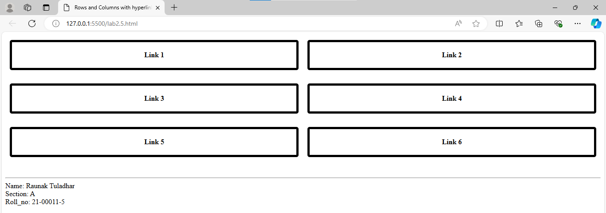

1. **Design an html form to demonstrate the 10 different types of controls generated using INPUT tag. Style the form as:**

**- Set the background color of textbox yellow when it is focused. - Change the text color blue to textbox.**

**- Increase the height of combo options when it is checked.**

**- Set the border color red if the input is invalid in textbox and textarea.**

**- Set green border to valid input.**

**- Design the form using fieldset.**

**HTML:**

<!DOCTYPE html>

<html lang="en">

<head>

<meta charset="UTF-8">

<meta name="viewport" content="width=device-width, initial-scale=1.0">

<title>Document</title>

<link rel="stylesheet" href="CSS_21-00011-5/lab2.6.css">

</head>

<body>

<h1>HTML Form</h1>

<form action="#" method="post">

<fieldset>

<legend>Personal Information</legend>

<label for="name">Name:</label>

<input type="text" id="name" name="name" required><br><br>

<label for="password">Password:</label>

<input type="password" id="password" name="password" required><br><br>

<label>Gender:</label>

<input type="radio" id="male" name="gender" value="male">

<label for="male">Male</label>

<input type="radio" id="female" name="gender" value="female">

<label for="female">Female</label><br><br>

<label for="hobbies">Hobbies:</label><br>

<input type="checkbox" id="reading" name="hobbies" value="reading">

<label for="reading">Reading</label><br>

<input type="checkbox" id="traveling" name="hobbies" value="traveling">

<label for="traveling">Traveling</label><br>

<input type="checkbox" id="gaming" name="hobbies" value="gaming">

<label for="gaming">Gaming</label><br><br>

<label for="email">Email:</label>

<input type="email" id="email" name="email" required><br><br>

<label for="age">Age:</label>

<input type="number" id="age" name="age" min="1" max="100" required><br><br>

<label for="dob">Date of Birth:</label>

<input type="date" id="dob" name="dob" required><br><br>

<label for="website">Website:</label>

<input type="url" id="website" name="website" required><br><br>

<label for="resume">Upload Resume:</label>

<input type="file" id="resume" name="resume"><br><br>

<input type="hidden" name="user_id" value="12345">

<input type="submit" value="Submit">

<input type="reset" value="Reset">

</fieldset>

</form>

<br>

<hr>

<footer>

Name: Raunak Tuladhar <br>

Section: A <br>

Roll_no: 21-00011-5

</footer>

</body>

</html>

**CSS:**

input[type="text"]:focus,

input[type="password"]:focus,

input[type="email"]:focus,

input[type="number"]:focus,

input[type="date"]:focus,

input[type="url"]:focus {

    background-color: yellow;

}

input[type="text"],

input[type="password"],

input[type="email"],

input[type="number"],

input[type="date"],

input[type="url"] {

    color: blue;

}

input[type="checkbox"]:checked {

    height: 25px;

}

input:invalid,

textarea:invalid {

    border-color: red;

}

input:valid,

textarea:valid {

    border-color: green;

}

fieldset {

    border: 2px solid #007bff;

    padding: 10px;

    border-radius: 5px;

}

**Output:**

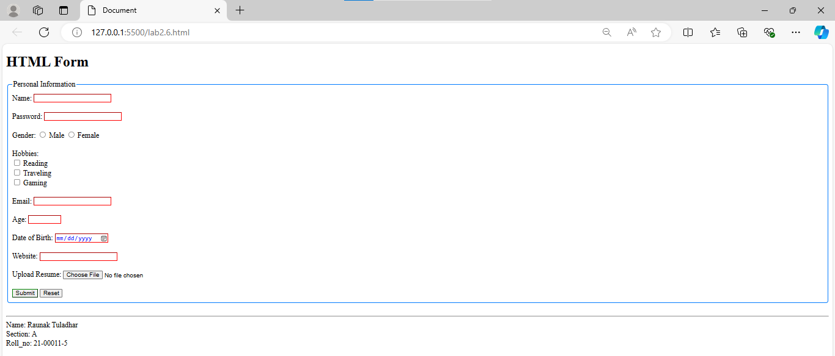

7. **Design the given table and style as:**

|  |  |
| --- | --- |
| **Class A** | **Class B** |
| **Class C** | **Class D** |

**- Set the border of any style and color.**

**- Set width of all Classes 600 pixel and height 550 pixel.**

**- Set different background color for all classes.**

**- Every text color should be different.**

**- Display Class C and Class D in uppercase and remaining in lower case.**

**HTML:**

<!DOCTYPE html>

<html lang="en">

<head>

    <meta charset="UTF-8">

    <meta name="viewport" content="width=device-width, initial-scale=1.0">

    <title>Table and style</title>

    <link rel="stylesheet" href="CSS_21-00011-5/lab2.7.css">

</head>

<body>

    <table>

        <tr>

            <td class="class-a">class a</td>

            <td class="class-b">class b</td>

        </tr>

        <tr>

            <td class="class-c">class c</td>

            <td class="class-d">class d</td>

        </tr>

    </table>

    <br>

    <hr>

    <footer>

        Name: Raunak Tuladhar <br>

        Section: A <br>

        Roll_no: 21-00011-5

    </footer>

</body>

</html>

**CSS:**

table {

    border-collapse: collapse;

   }

   td {

    border: 2px solid black;

    width: 300px;

    height: 100px;

    text-align: center;

    vertical-align: middle;

    font-size: 24px;

    font-weight: bold;

   }

   .class-a {

    background-color: lightblue;

    color: darkblue;

    text-transform: lowercase;

   }

   .class-b {

    background-color: lightgreen;

    color: darkgreen;

    text-transform: lowercase;

   }

   .class-c {

    background-color: lightcoral;

    color: darkred;

    text-transform: uppercase;

   }

   .class-d {

    background-color: lightyellow;

    color: darkorange;

    text-transform: uppercase;

   }

**Output:**

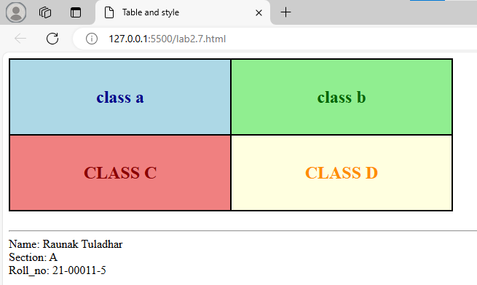

**8. Design a horizontal menu of any five options and style as:**

**- Set border for all links.**

**- Set different background color and text color.**

**- Change the font color and increase the font size when mouse over it.**

**- Remove the underline from link.**

**- Change all the default behavior of links.**

<!DOCTYPE html>

<html lang="en">

<head>

<meta charset="UTF-8">

<meta name="viewport" content="width=device-width, initial-scale=1.0">

<title>Menu</title>

<style>

nav ul {

list-style-type: none;

margin: 0;

padding: 0;

overflow: hidden;

background-color: #333;

}

nav ul li {

float: left;

}

nav ul li a {

display: block;

color: white;

text-align: center;

padding: 14px 20px;

text-decoration: none;

background-color: #4CAF50;

border: 2px solid white;

transition: all 0.3s ease;

}

nav ul li a:hover {

background-color: #ddd;

color: black;

font-size: 18px;

}

nav ul li a:active {

background-color: #555;

color: white;

}

nav ul li a:visited {

color: #ffcc00;

}

nav ul li a:link {

color: white;

}

</style>

</head>

<body>

<nav>

<ul>

<li><a href="#">Home</a></li>

<li><a href="#">About</a></li>

<li><a href="#">Services</a></li>

<li><a href="#">Portfolio</a></li>

<li><a href="#">Contact</a></li>

</ul>

<br>

<hr>

<footer>

Name: Raunak Tuladhar <br>

Section: A <br>

Roll_no: 21-00011-5

</footer>

</body>

</html>

**Output:**

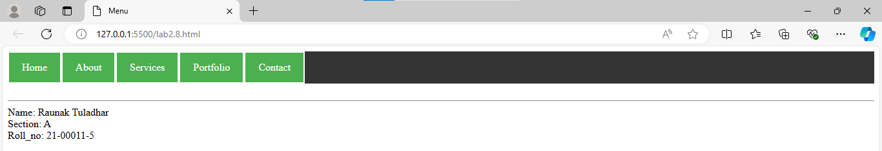

1. **Develop a web page with a paragraph and add some contents before the paragraph with red color and yellow background using CSS.**

<!DOCTYPE html>

<html lang="en">

<head>

<meta charset="UTF-8">

<meta name="viewport" content="width=device-width, initial-scale=1.0">

<title>Paragraph styling</title>

<style>

.styled-paragraph::before {

content: "This is the added content before the paragraph. ";

color: red;

background-color: yellow;

padding: 5px;

}

</style>

</head>

<body>

<p class="styled-paragraph">This is the main paragraph content. It contains some information that follows the added content.</p>

<br>

<hr>

<footer>

Name: Raunak Tuladhar <br>

Section: A <br>

Roll_no: 21-00011-5

</footer>

</body>

</html>

**Output:**

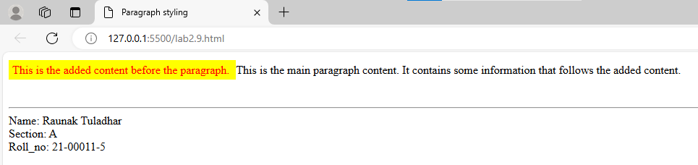

1. **Illustrate the concept of pseudo elements with example. (::after, ::first-letter, ::selection, ::first-line)**

<!DOCTYPE html>

<html lang="en">

<head>

<meta charset="UTF-8">

<meta name="viewport" content="width=device-width, initial-scale=1.0">

<title>Pseudo Elements</title>

<style>

.example-paragraph::after {

content: " - End of this example.";

color: blue;

font-weight: bold;

}

.example-paragraph::first-letter {

font-size: 3em;

color: green;

font-weight: bold;

float: left;

margin-right: 5px;

line-height: 1;

}

.example-paragraph::first-line {

color: red;

font-weight: bold;

}

.example-paragraph::selection {

background-color: yellow;

color: black;

}

</style>

</head>

<body>

<p class="example-paragraph">Pseudo-elements are used to style specific parts of an element's content. These can be

powerful tools for designers who want to apply styles to parts of content that are not directly selectable in the HTML structure.

This paragraph demonstrates the use of several pseudo-elements together.</p>

<br>

<hr>

<footer>

Name: Raunak Tuladhar <br>

Section: A <br>

Roll_no: 21-00011-5

</footer>

</body>

</html>

**Output:**

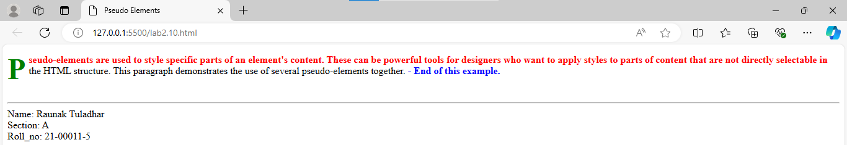

1. **Design following list using html and CSS**

**✓ Mouse**

**✓ Keyboard**

**✓ Monitor**

**✓ Printer**

**✓ Touchpad**

<!DOCTYPE html>

<html lang="en">

<head>

    <meta charset="UTF-8">

    <meta name="viewport" content="width=device-width, initial-scale=1.0">

    <title>List</title>

    <style>

        ul {

 list-style: none;

 }

 ul li:before {

 content: '✓';

 }

    </style>

</head>

<body>

    <ul>

        <li>Mouse</li>

        <li>Keyboard</li>

        <li>Monitor</li>

        <li>Printer</li>

        <li>Touchpad</li>

    </ul>

    <br>

    <hr>

    <footer>

        Name: Raunak Tuladhar <br>

        Section: A <br>

        Roll_no: 21-00011-5

    </footer>

</body>

</html>

**Output:**

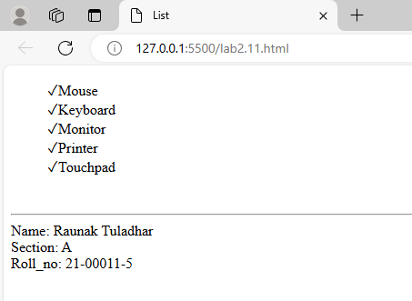

**Lab 3: Javascript**

1. **Declare variables of different data types (string, number, boolean). Perform operations on these variables and display the results using console.log().**

let StringValue_11 = "Hello";

let NumValue_11 = 13;

let BoolValue_11 = true;

let StringConcat_11 = StringValue_11 +"," + "How are you?";

let NumSum_11 = NumValue_11 + 20;

let BoolToogle_11 = !BoolValue_11;

console.log("String Concatenation: " + StringConcat_11);

console.log("Sum of Numbers: " + NumSum_11);

console.log("Boolean Toogle: " + BoolToogle_11);

console.log("\nName: Raunak Tuladhar");

console.log("Roll_no: 21-00011-5");

**Output:**

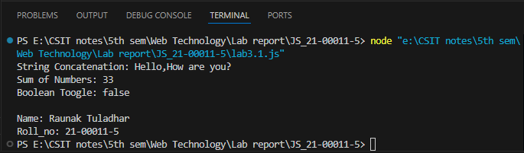

1. **Write a JavaScript program that uses if-else statements to determine if a number is even or odd. Implement a loop to print numbers from 1 to 10.**

for (let i_11 = 1; i_11 <= 10; i_11++) {

if (i_11 % 2 === 0) {

console.log(i_11 + " is even");

}

else {

console.log(i_11 + " is odd");

}

}

console.log("\nName: Raunak Tuladhar");

console.log("Roll_no: 21-00011-5");

**Output:**

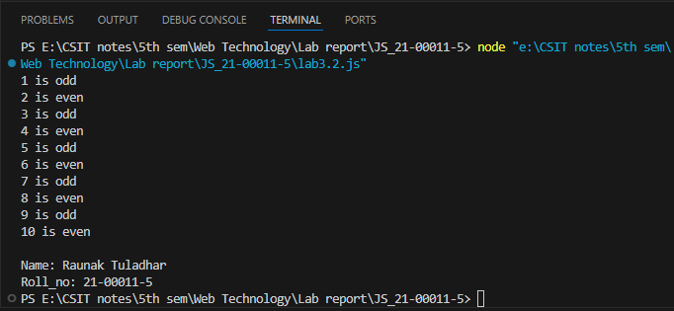

1. **Create a function that accepts user input using the prompt method and displays the input using an alert box. Use a confirm box to ask the user for a yes/no response and display the result.**

**HTML:**

<!DOCTYPE html>

<html lang="en">

<head>

<meta charset="UTF-8">

<meta name="viewport" content="width=device-width, initial-scale=1.0">

<title>Accept user input</title>

</head>

<body>

<script src="lab3.3.js"></script>

<br>

<hr>

<footer>

Name: Raunak Tuladhar <br>

Section: A <br>

Roll_no: 21-00011-5

</footer>

</body>

</html>

**JS:**

function getUserInput_11() {

let userInput_11 = prompt("Please enter something:");

alert("You entered: " + userInput_11);

let userResponse_11 = confirm("Do you want to proceed?");

if (userResponse_11) {

alert("You chose to proceed!");

}

else {

alert("You chose not to proceed.");

}

}

getUserInput_11();

console.log("\nName: Raunak Tuladhar");

console.log("Roll_no: 21-00011-5");

**Output:**

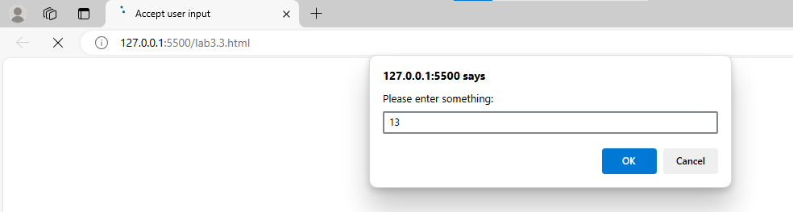

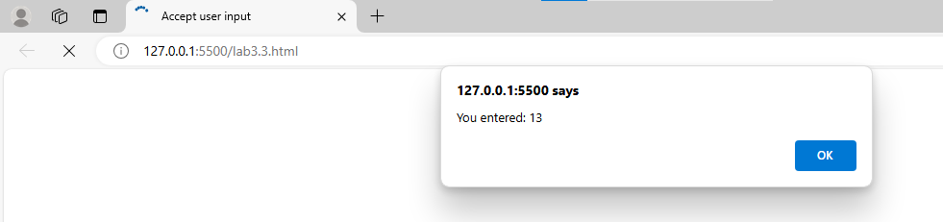

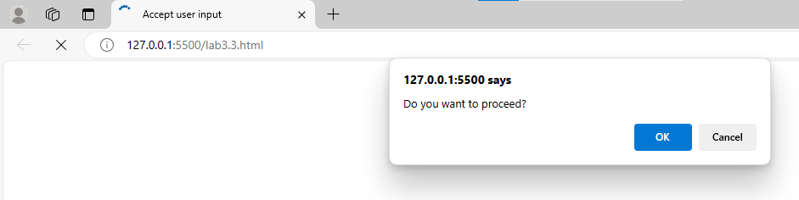

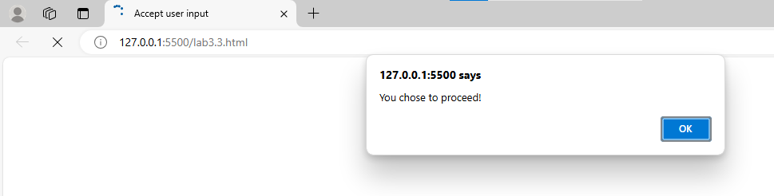

1. **Define an object representing a person with properties like name, age, and address. Access and display these properties using console.log().**

let person_11 = {

name_11: "Raunak Tuladhar",

age_11: 21,

address_11: "Asan-27, Kathmandu"

};

console.log("Name: " + person_11.name_11);

console.log("Age: " + person_11.age_11);

console.log("Address: " + person_11.address_11);

console.log("\nName: Raunak Tuladhar");

console.log("Roll_no: 21-00011-5");

**Output:**

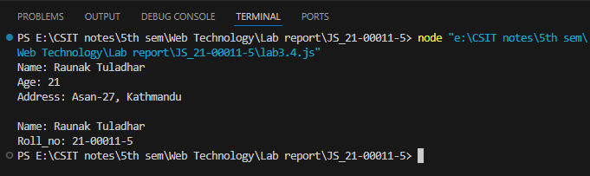

1. **Declare an array of colors. Use a loop to iterate through the array and display each color on the webpage in HTML table.**

**HTML:**

<!DOCTYPE html>

<html lang="en">

<head>

<meta charset="UTF-8">

<meta name="viewport" content="width=device-width, initial-scale=1.0">

<title>Display each Colour in table</title>

</head>

<body>

<table id="colorTable" border="1">

<tr>

<th>Color</th>

</tr>

</table>

<script src="lab3.5.js"></script>

<br>

<hr>

<footer>

Name: Raunak Tuladhar <br>

Section: A <br>

Roll_no: 21-00011-5

</footer>

</body>

</html>

**JS:**

const colors_11 = ['Red', 'Green', 'Blue', 'Yellow', 'Orange', 'Purple'];

const table_11 = document.getElementById('colorTable');

let rows_11 = '';

for (let i = 0; i < colors_11.length; i++) {

rows_11 += `<tr><td>${colors_11[i]}</td></tr>`;

}

table_11.innerHTML += rows_11;

**Output:**

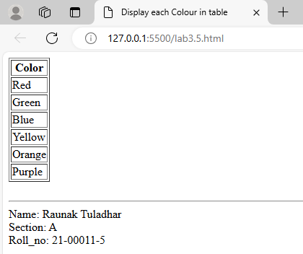

**6. Explain all the following built in objects with examples of each**

**- Array Methods**

**- Date Methods**

**- String Methods**

**- Math Methods**

console.log("Array Methods:");

let array_11 = [1, 2, 3];

array_11.push(4, 5);

console.log("Array after push:", array_11);

array_11.pop();

console.log("Array after pop:", array_11);

array_11.shift();

console.log("Array after shift:", array_11);

array_11.unshift(1);

console.log("Array after unshift:", array_11);

console.log("\nDate Methods:");

let date_11 = new Date();

console.log("Current Date:", date_11);

console.log("Day of the month:", date_11.getDate());

console.log("Month index:", date_11.getMonth());

console.log("Full year:", date_11.getFullYear());

date_11.setDate(15);

console.log("Updated Day of the month:", date_11.getDate());

console.log("Localized Date String:", date_11.toLocaleDateString());

console.log("\nString Methods:");

let str_11 = "Hello, World!";

console.log("Original String:", str_11);

console.log("Uppercase:", str_11.toUpperCase());

console.log("Lowercase:", str_11.toLowerCase());

console.log("Substring (7, 12):", str_11.substring(7, 12));

console.log("Replaced String:", str_11.replace("World", "Universe"));

console.log("Split String:", str_11.split(","));

console.log("\nMath Methods:");

console.log("Max value:", Math.max(1, 2, 3, 4, 5));

console.log("Min value:", Math.min(1, 2, 3, 4, 5));

console.log("Rounded value (4.7):", Math.round(4.7));

console.log("Random value:", Math.random());

console.log("Floor value (4.7):", Math.floor(4.7));

console.log("\nName: Raunak Tuladhar");

console.log("Roll_no: 21-00011-5");

**Output:**

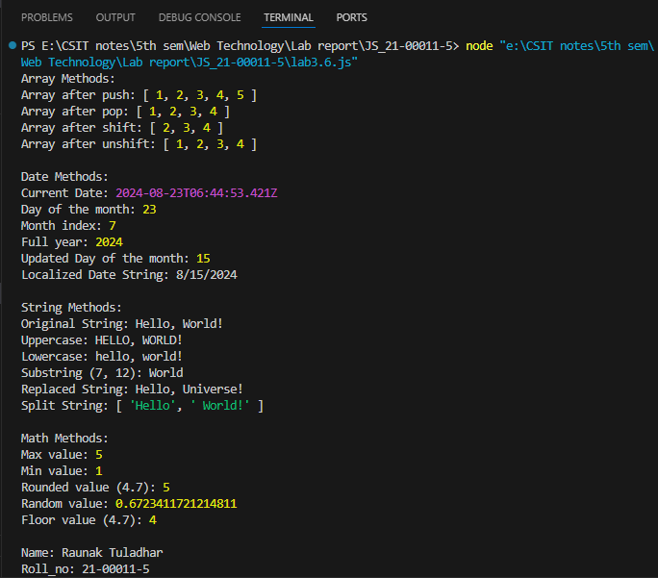

1. **Utilize the Date object to display the current date and time.**

let currentDateTime_11 = new Date();

console.log("Current Date and Time:");

console.log("Date and Time:", currentDateTime_11.toLocaleString());

console.log("\nName: Raunak Tuladhar");

console.log("Roll_no: 21-00011-5");

**Output:**

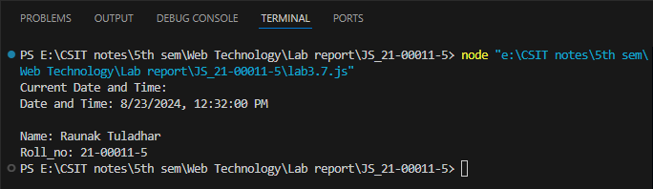

1. **Use the Math object to perform a mathematical operation (e.g., random number generation).**

let randomNumber_11 = Math.random();

console.log("Random Number between 0 and 1:", randomNumber_11);

let min_11 = 1;

let max_11 = 100;

let randomInteger_11 = Math.floor(Math.random() * (max_11 - min_11 + 1)) + min_11;

console.log("Random Integer between 1 and 100:", randomInteger_11);

let num_11 = 9;

console.log("Square root of 9:", Math.sqrt(num_11));

console.log("Power of 2^3:", Math.pow(2, 3));

console.log("Absolute value of -5:", Math.abs(-5));

console.log("\nName: Raunak Tuladhar");

console.log("Roll_no: 21-00011-5");

Output:

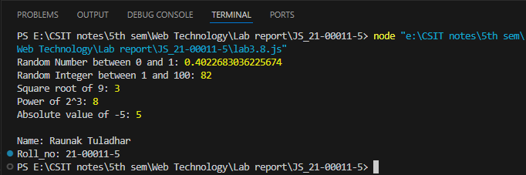

1. **Create a user-defined object representing a car. Implement an event handler that triggers when a button is clicked, updating the car's properties.**

**HTML:**

<!DOCTYPE html>

<html lang="en">

<head>

<meta charset="UTF-8">

<meta name="viewport" content="width=device-width, initial-scale=1.0">

<title>User Defined Object</title>

</head>

<body>

<h2>Car Information</h2>

<p id="car-make">Make: Toyota</p>

<p id="car-model">Model: Corolla</p>

<p id="car-year">Year: 2020</p>

<button id="updateButton_11">Update Car Properties</button>

<script src="lab3.9.js"></script>

<br>

<hr>

<footer>

Name: Raunak Tuladhar <br>

Section: A <br>

Roll_no: 21-00011-5

</footer>

</body>

</html>

**JS:**

const car_11 = {

make_11: 'Toyota',

model_11: 'Corolla',

year_11: 2020,

displayProperties_11() {

console.log(`Car - Make: ${this.make_11}, Model: ${this.model_11}, Year: ${this.year_11}`);

document.getElementById('car-make').textContent = `Make: ${this.make_11}`;

document.getElementById('car-model').textContent = `Model: ${this.model_11}`;

document.getElementById('car-year').textContent = `Year: ${this.year_11}`;

},

updateProperties_11(make, model, year) {

this.displayProperties_11();

this.make_11 = make;

this.model_11 = model;

this.year_11 = year;

this.displayProperties_11();

console.log(`Updated Car - Make: ${this.make_11}, Model: ${this.model_11}, Year: ${this.year_11}`);

}

};

function updateCarProperties_11() {

car_11.updateProperties_11('Lamborghini', 'Urus', 2018);

}

document.getElementById('updateButton_11').addEventListener('click', updateCarProperties_11);

car_11.displayProperties_11();

console.log("\nName: Raunak Tuladhar");

console.log("Roll_no: 21-00011-5");

**Output:**

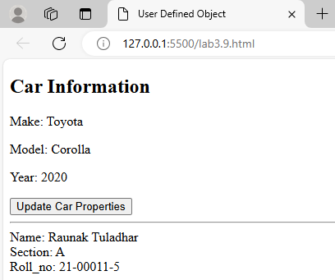

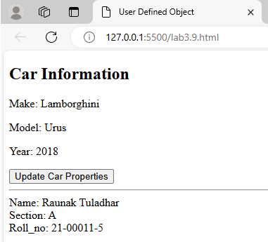

1. **Write a JavaScript program that includes a try-catch block to handle potential errors. Trigger an error intentionally and observe how it's caught.**

function divideNumbers_11(a, b) {

try {

if (b === 0) {

throw new Error("Cannot divide by zero.");

}

let result_11 = a / b;

console.log("Result:", result_11);

} catch (error_11) {

console.error("An error occurred:", error_11.message);

} finally {

console.log("Division attempt completed.");

}

}

divideNumbers_11(10, 0);

divideNumbers_11(10, 2);

console.log("\nName: Raunak Tuladhar");

console.log("Roll_no: 21-00011-5");

**Output:**

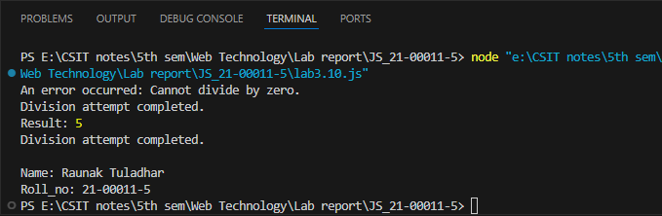

1. **How events are handled in JavaScript? Illustrate with examples.**

<!DOCTYPE html>

<html lang="en">

<head>

<meta charset="UTF-8">

<meta name="viewport" content="width=device-width, initial-scale=1.0">

<title>Event handling in JS</title>

<style>

#hover_11{

width: 200px;

height: 100px;

background-color: lightblue;

margin-bottom: 20px;

}

</style>

</head>

<body>

<h1>Event Handling in Js</h1>

<button id="myButton_11">Click Me!</button>

<p id="message_11"></p>

<div id="hoverArea_11">Hover over me!</div>

<p id="hoverMessage_11"></p>

<script>

document.getElementById('myButton_11').addEventListener('click', function() {

document.getElementById('message_11').textContent = 'Button was clicked!';

});

const hoverArea_11 = document.getElementById('hoverArea_11');

hoverArea_11.addEventListener('mouseover', function() {

document.getElementById('hoverMessage_11').textContent = 'Mouse is over the area!';

});

hoverArea_11.addEventListener('mouseout', function() {

document.getElementById('hoverMessage_11').textContent = 'Mouse left the area!';

});

</script>

<br>

<hr>

<footer>

Name: Raunak Tuladhar <br>

Section: A <br>

Roll_no: 21-00011-5

</footer>

</body>

</html>

**Output:**

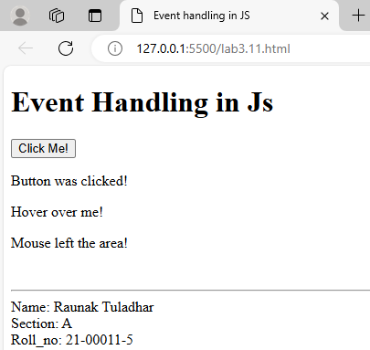

1. **Implement JavaScript code to set and retrieve cookies. Display the stored cookie information on the webpage.**

<!DOCTYPE html>

<html lang="en">

<head>

<meta charset="UTF-8">

<meta name="viewport" content="width=device-width, initial-scale=1.0">

<title>Cookies</title>

</head>

<body>

<h1>Cookie</h1>

<input type="text" id="cookieName_11" placeholder="Cookie Name">

<input type="text" id="cookieValue_11" placeholder="Cookie Value">

<button id="setCookieButton_11">Set Cookie</button>

<p id="cookieDisplay_11">No cookies set.</p>

<script>

function setCookie_11(name, value, days) {

let expires_11 = "";

if (days) {

const date_11 = new Date();

date_11.setTime(date_11.getTime() + (days * 24 * 60 * 60 * 1000));

expires_11 = "expires=" + date_11.toUTCString();

}

document.cookie = name + "=" + (value || "") + ";" + expires_11 + ";path=/";

}

function getCookie_11(name) {

const nameEQ_11 = name + "=";

const ca_11 = document.cookie.split(';');

for (let i = 0; i < ca_11.length; i++) {

let c_11 = ca_11[i];

while (c_11.charAt(0) === ' ') c_11 = c_11.substring(1);

if (c_11.indexOf(nameEQ_11) === 0) return c_11.substring(nameEQ_11.length, c_11.length);

}

return null;

}

function displayCookies_11() {

const cookies_11 = document.cookie.split(';').map(cookie => cookie.trim()).join('; ');

document.getElementById('cookieDisplay_11').textContent = cookies_11 || 'No cookies set.';

}

document.getElementById('setCookieButton_11').addEventListener('click', function () {

const name_11 = document.getElementById('cookieName_11').value;

const value_11 = document.getElementById('cookieValue_11').value;

setCookie_11(name_11, value_11, 1);

displayCookies_11();

});

displayCookies_11();

</script>

</body>

</html>

**Output:**

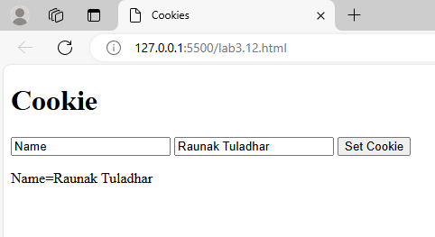

1. **Integrate jQuery into an HTML document. Use different selectors (element, ID, class) to manipulate elements on the webpage.**

<!DOCTYPE html>

<html lang="en">

<head>

<meta charset="UTF-8">

<meta name="viewport" content="width=device-width, initial-scale=1.0">

<title>jQuery Selectors</title>

<style>

.highlight_11 {

background-color: yellow;

}

.hidden_11 {

display: none;

}

</style>

<script src="https://code.jquery.com/jquery-3.6.0.min.js"></script>

</head>

<body>

<h1>jQuery Selectors</h1>

<p class="text_11">This is a paragraph with class 'text_11'.</p>

<p id="special_11">This is a paragraph with ID 'special_11'.</p>

<p class="text_11">Another paragraph with class 'text_11'.</p>

<button id="changeTextButton_11">Change Text</button>

<button id="toggleClassButton_11">Toggle Highlight</button>

<button id="hideShowButton_11">Hide/Show Paragraph</button>

<script>

$(document).ready(function () {

$('#changeTextButton_11').click(function () {

$('#special_11').text('The text has been changed using jQuery!');

});

$('#toggleClassButton_11').click(function () {

$('.text_11').toggleClass('highlight_11');

});

$('#hideShowButton_11').click(function () {

$('.text_11').toggleClass('hidden_11');

});

});

</script>

<br>

<hr>

<footer>

Name: Raunak Tuladhar <br>

Section: A <br>

Roll_no: 21-00011-5

</footer>

</body>

</html>

**Output:**

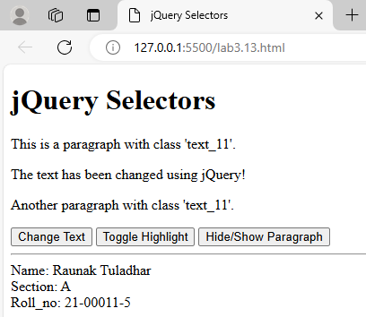

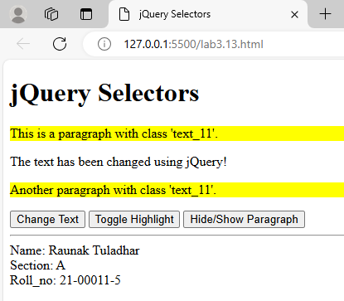

1. **Implement jQuery events for mouse interactions (e.g., click, hover) on specific elements. Display relevant information when these events occur.**

<!DOCTYPE html>

<html lang="en">

<head>

<meta charset="UTF-8">

<meta name="viewport" content="width=device-width, initial-scale=1.0">

<title>jQuery Mouse Events</title>

<script src="https://code.jquery.com/jquery-3.6.0.min.js"></script>

</head>

<body>

<h1>jQuery Mouse Events</h1>

<div id="box_11"

style="width: 200px; height: 100px; background-color: lightblue; text-align: center; line-height: 100px; margin-bottom:

20px;">

Hover over me!

</div>

<p id="eventDisplay_11">No event occurred yet.</p>

<script>

$(document).ready(function () {

$('#box_11').hover(

function () {

$('#eventDisplay_11').text('Mouse is over the area!');

},

function () {

$('#eventDisplay_11').text('Mouse left the area!');

}

);

$('#box_11').click(function () {

$('#eventDisplay_11').text('Area was clicked!');

});

});

</script>

<br>

<hr>

<footer>

Name: Raunak Tuladhar <br>

Section: A <br>

Roll_no: 21-00011-5

</footer>

</body>

</html>

**Output:**

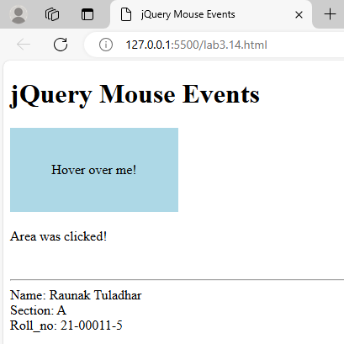

1. **Apply various jQuery effects (hide, show, fade, slide) to elements on the webpage. Create a button that triggers a combination of these effects.**

<!DOCTYPE html>

<html lang="en">

<head>

<meta charset="UTF-8">

<meta name="viewport" content="width=device-width, initial-scale=1.0">

<title>jQuery Effects</title>

<script src="https://code.jquery.com/jquery-3.6.0.min.js"></script>

</head>

<body>

<h1>jQuery Effects</h1>

<div id="effectBox_11"

style="width: 200px; height: 100px; background-color: lightcoral; text-align: center; line-height: 100px; margin-bottom:

20px;">

Effect Box

</div>

<button id="hideButton_11">Hide</button>

<button id="showButton_11">Show</button>

<button id="fadeButton_11">Fade</button>

<button id="slideButton_11">Slide</button>

<button id="comboButton_11">Combo Effect</button>

<script>

$(document).ready(function () {

$('#hideButton_11').click(function () {

$('#effectBox_11').hide();

});

$('#showButton_11').click(function () {

$('#effectBox_11').show();

});

$('#fadeButton_11').click(function () {

$('#effectBox_11').fadeToggle();

});

$('#slideButton_11').click(function () {

$('#effectBox_11').slideToggle();

});

$('#comboButton_11').click(function () {

$('#effectBox_11').slideUp(500)

.slideDown(500)

.fadeOut(500)

.fadeIn(500);

});

});

</script>

<br>

<hr>

<footer>

Name: Raunak Tuladhar <br>

Section: A <br>

Roll_no: 21-00011-5

</footer>

</body>

</html>

**Output:**

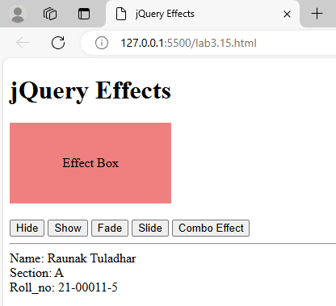

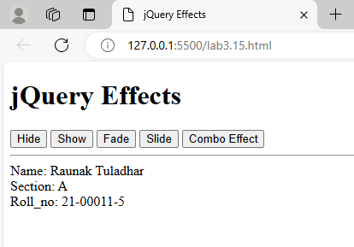

1. **Create a JSON object representing information about a book. Parse and display the data using JavaScript.**

let bookJSON_11 = `{

"title": "To Kill a Mockingbird",

"author": "Harper Lee",

"publicationYear": 1960,

"genre": "Fiction",

"ISBN": "978-0-06-112008-4"

}`;

let book_11 = JSON.parse(bookJSON_11);

console.log("Book Information:");

console.log("Title: " + book_11.title);

console.log("Author: " + book_11.author);

console.log("Publication Year: " + book_11.publicationYear);

console.log("Genre: " + book_11.genre);

console.log("ISBN: " + book_11.ISBN);

console.log("\nName: Raunak Tuladhar");

console.log("Roll_no: 21-00011-5");

**Output:**

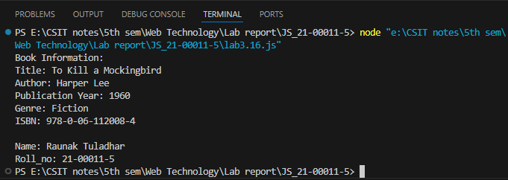

1. **Write a JavaScript program that uses JSON to represent an array of students with different data types. Extract and display information from this JSON structure.**

let studentsJSON_11 = `[

{

"name": "Suman Shrestha",

"age": 21,

"enrolled": true,

"courses": ["Mathematics", "Physics", "Nepali"]

},

{

"name": "Anjali Karki",

"age": 23,

"enrolled": false,

"courses": ["Economics", "Business Studies"]

},

{

"name": "Bikash Rai",

"age": 22,

"enrolled": true,

"courses": ["Biology", "Chemistry", "Nepali"]

}

]`;

let students_11 = JSON.parse(studentsJSON_11);

console.log("Nepali Student Information:");

students_11.forEach(function(student_11, index_11) {

console.log("\nStudent " + (index_11 + 1) + ":");

console.log("Name: " + student_11.name);

console.log("Age: " + student_11.age);

console.log("Enrolled: " + (student_11.enrolled ? "Yes" : "No"));

console.log("Courses: " + student_11.courses.join(", "));

});

console.log("\nName: Raunak Tuladhar");

console.log("Roll_no: 21-00011-5");

**Output:**

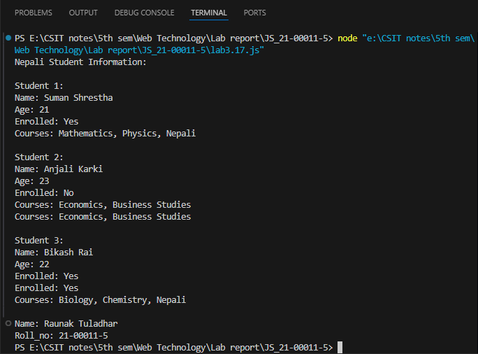

1. **Develop a form with input fields. Use jQuery to validate the form, providing feedback to users for correct or incorrect entries.**

<!DOCTYPE html>

<html lang="en">

<head>

<meta charset="UTF-8">

<meta name="viewport" content="width=device-width, initial-scale=1.0">

<title>Basic Form Validation with jQuery</title>

<style>

.error_11 {

color: red;

}

.success_11 {

color: green;

}

</style>

<script src="https://code.jquery.com/jquery-3.6.0.min.js"></script>

</head>

<body>

<h1>Basic Form Validation</h1>

<form id="basicForm_11">

<label for="name_11">Name:</label>

<input type="text" id="name_11" name="name_11"><br><br>

<label for="age_11">Age:</label>

<input type="number" id="age_11" name="age_11"><br><br>

<input type="submit" value="Submit">

</form>

<p id="feedback_11"></p>

<script>

$(document).ready(function () {

$('#basicForm_11').submit(function (event) {

event.preventDefault();

let name_11 = $('#name_11').val();

let age_11 = $('#age_11').val();

let valid_11 = true;

let feedback_11 = '';

if (name_11 === '') {

valid_11 = false;

feedback_11 += '<p class="error_11">Name is required.</p>';

} else {

feedback_11 += '<p class="success_11">Name is ok.</p>';

}

if (age_11 === '' || age_11 <= 0) {

valid_11 = false;

feedback_11 += '<p class="error_11">Please enter a valid age.</p>';

} else {

feedback_11 += '<p class="success_11">Age is ok.</p>';

}

$('#feedback_11').html(feedback_11);

if (valid_11) {

alert("Form submitted successfully!");

}

});

});

</script>

<br>

<hr>

<footer>

Name: Raunak Tuladhar <br>

Section: A <br>

Roll_no: 21-00011-5

</footer>

</body>

</html>

**Output:**

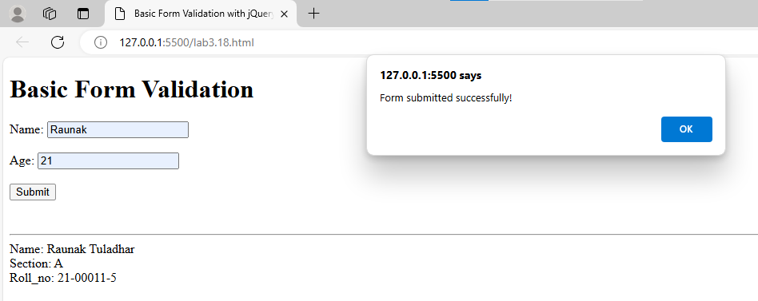

1. **Extend the previous form validation example to include more complex validation requirements. Validate email addresses, ensure passwords match, and check if a phone number follows a specific format.**

<!DOCTYPE html>

<html lang="en">

<head>

<meta charset="UTF-8">

<meta name="viewport" content="width=device-width, initial-scale=1.0">

<title>Form Validation with jQuery</title>

<style>

.error_11 {

color: red;

}

.success_11 {

color: green;

}

</style>

<script src="https://code.jquery.com/jquery-3.6.0.min.js"></script>

</head>

<body>

<h1>Extended Form Validation</h1>

<form id="extendedForm_11">

<label for="name_11">Name:</label>

<input type="text" id="name_11" name="name_11"><br><br>

<label for="email_11">Email:</label>

<input type="email" id="email_11" name="email_11"><br><br>

<label for="password_11">Password:</label>

<input type="password" id="password_11" name="password_11"><br><br>

<label for="confirmPassword_11">Confirm Password:</label>

<input type="password" id="confirmPassword_11" name="confirmPassword_11"><br><br>

<label for="phone_11">Phone Number:</label>

<input type="text" id="phone_11" name="phone_11" placeholder="e.g., 9841234567"><br><br>

<input type="submit" value="Submit">

</form>

<p id="feedback_11"></p>

<script>

$(document).ready(function () {

$('#extendedForm_11').submit(function (event) {

event.preventDefault();

let name_11 = $('#name_11').val();

let email_11 = $('#email_11').val();

let password_11 = $('#password_11').val();

let confirmPassword_11 = $('#confirmPassword_11').val();

let phone_11 = $('#phone_11').val();

let valid_11 = true;

let feedback_11 = '';

if (name_11 === '') {

valid_11 = false;

feedback_11 += '<p class="error_11">Name is required.</p>';

} else {

feedback_11 += '<p class="success_11">Name is ok.</p>';

}

let emailPattern_11 = /^[a-zA-Z0-9._-]+@[a-zA-Z0-9.-]+\.[a-zA-Z]{2,6}$/;

if (email_11 === '' || !emailPattern_11.test(email_11)) {

valid_11 = false;

feedback_11 += '<p class="error_11">Please enter a valid email address.</p>';

} else {

feedback_11 += '<p class="success_11">Email is ok.</p>';

}

if (password_11 === '' || confirmPassword_11 === '') {

valid_11 = false;

feedback_11 += '<p class="error_11">Password fields cannot be empty.</p>';

} else if (password_11 !== confirmPassword_11) {

valid_11 = false;

feedback_11 += '<p class="error_11">Passwords do not match.</p>';

} else {

feedback_11 += '<p class="success_11">Passwords match.</p>';

}

let phonePattern_11 = /^98\d{8}$/;

if (phone_11 === '' || !phonePattern_11.test(phone_11)) {

valid_11 = false;

feedback_11 += '<p class="error_11">Please enter a valid phone number of Npl.</p>';

} else {

feedback_11 += '<p class="success_11">Phone number is ok.</p>';

}

$('#feedback_11').html(feedback_11);

if (valid_11) {

alert("Form submitted successfully!");

}

});

});

</script>

<br>

<hr>

<footer>

Name: Raunak Tuladhar <br>

Section: A <br>

Roll_no: 21-00011-5

</footer>

</body>

</html>

Output:

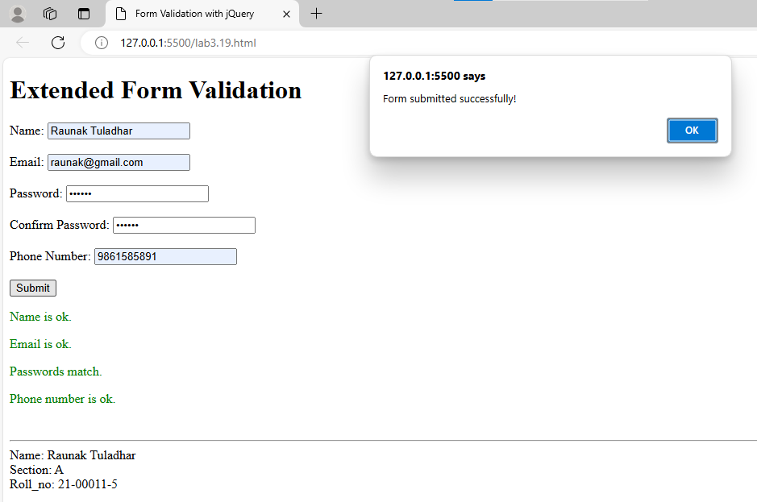

1. **How animation is done using jQuery? Illustrate with example.**

<!DOCTYPE html>

<html lang="en">

<head>

<meta charset="UTF-8">

<meta name="viewport" content="width=device-width, initial-scale=1.0">

<title>jQuery Animation Example</title>

<style>

#box_11 {

width: 100px;

height: 100px;

background-color: blue;

position: relative;

margin-top: 15px;

}

</style>

<script src="https://code.jquery.com/jquery-3.6.0.min.js"></script>

</head>

<body>

<h1>jQuery Animation</h1>

<button id="animateBtn_11">Animate Box</button>

<div id="box_11"></div>

<script>

$(document).ready(function () {

$('#animateBtn_11').click(function () {

$('#box_11').animate({

width: '200px',

height: '200px',

left: '100px'

}, 1000, function () {

$(this).css('background-color', 'red');

});

});

});

</script>

<br>

<hr>

<footer>

Name: Raunak Tuladhar <br>

Section: A <br>

Roll_no: 21-00011-5

</footer>

</body>

</html>

**Output:**

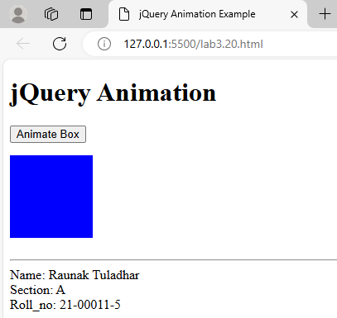

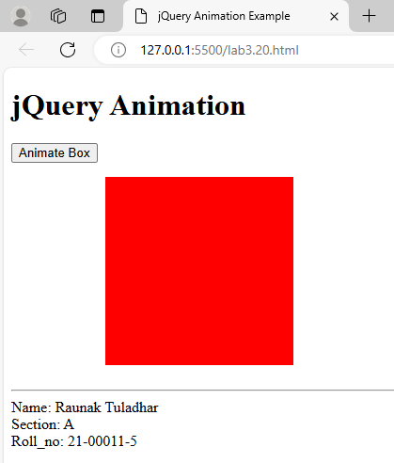

**21. WAP that contains a text field for name, age, phone number, email, dropdown for colleges, radio for gender and a checkbox for I accept all the terms. Perform the client-side validations in JavaScript as:**

**a. All fields are required**

**b. Name must contain alphabets and white spaces and of length greater than 6 characters long**

**c. Age must be integer and must be between and 50**

**d. Phone number must be exactly 10 digits long and must start with 98 or 97**

**e. Email must be valid**

<!DOCTYPE html>

<html lang="en">

<head>

<meta charset="UTF-8">

<meta name="viewport" content="width=device-width, initial-scale=1.0">

<title>Form Validation in JS</title>

<style>

.error_11 {

color: red;

}

</style>

</head>

<body>

<h1>Form Validation Example</h1>

<form id="registrationForm_11">

<label for="name_11">Name:</label>

<input type="text" id="name_11" name="name_11"><br><br>

<label for="age_11">Age:</label>

<input type="number" id="age_11" name="age_11"><br><br>

<label for="phone_11">Phone Number:</label>

<input type="text" id="phone_11" name="phone_11"><br><br>

<label for="email_11">Email:</label>

<input type="email" id="email_11" name="email_11"><br><br>

<label for="college_11">College:</label>

<select id="college_11" name="college_11">

<option value="">Select your college</option>

<option value="Tribhuwan University">Tribhuwan University</option>

<option value="Kathmandu University">Kathmandu University</option>

<option value="Pokhara University">Pokhara University</option>

</select><br><br <label>Gender:</label>

<input type="radio" id="male_11" name="gender_11" value="male">

<label for="male_11">Male</label>

<input type="radio" id="female_11" name="gender_11" value="female">

<label for="female_11">Female</label><br><br>

<label>

<input type="checkbox" id="terms_11" name="terms_11">

I accept all the terms.

</label><br><br>

<input type="submit" value="Register">

</form>

<p id="feedback_11" class="error_11"></p>

<script>

document.getElementById('registrationForm_11').addEventListener('submit', function (event) {

event.preventDefault();

let feedback_11 = '';

let valid_11 = true;

let name_11 = document.getElementById('name_11').value.trim();

let age_11 = document.getElementById('age_11').value.trim();

let phone_11 = document.getElementById('phone_11').value.trim();

let email_11 = document.getElementById('email_11').value.trim();

let college_11 = document.getElementById('college_11').value;

let gender_11 = document.querySelector('input[name="gender_11"]:checked');

let terms_11 = document.getElementById('terms_11').checked;

let namePattern_11 = /^[a-zA-Z\s]{7,}$/;

if (!name_11 || !namePattern_11.test(name_11)) {

valid_11 = false;

feedback_11 += '<p>Name must contain only alphabets and spaces and be at least 7 characters long.</p>';

}

if (!age_11 || isNaN(age_11) || age_11 < 1 || age_11 > 50) {

valid_11 = false;

feedback_11 += '<p>Age must be an integer between 1 and 50.</p>';

}

let phonePattern_11 = /^(98|97)\d{8}$/;

if (!phone_11 || !phonePattern_11.test(phone_11)) {

valid_11 = false;

feedback_11 += '<p>Phone number must be exactly 10 digits long and start with 98 or 97.</p>';

}

let emailPattern_11 = /^[a-zA-Z0-9._-]+@[a-zA-Z0-9.-]+\.[a-zA-Z]{2,6}$/;

if (!email_11 || !emailPattern_11.test(email_11)) {

valid_11 = false;

feedback_11 += '<p>Please enter a valid email address.</p>';

}

if (!college_11) {

valid_11 = false;

feedback_11 += '<p>Please select your college.</p>';

}

if (!gender_11) {

valid_11 = false;

feedback_11 += '<p>Please select your gender.</p>';

}

if (!terms_11) {

valid_11 = false;

feedback_11 += '<p>You must accept the terms and conditions.</p>';

}

document.getElementById('feedback_11').innerHTML = feedback_11;

if (valid_11) {

alert("Form submitted successfully!");

}

});

</script>

<br>

<hr>

<footer>

Name: Raunak Tuladhar <br>

Section: A <br>

Roll_no: 21-00011-5

</footer>

</body>

</html>

**Output:**

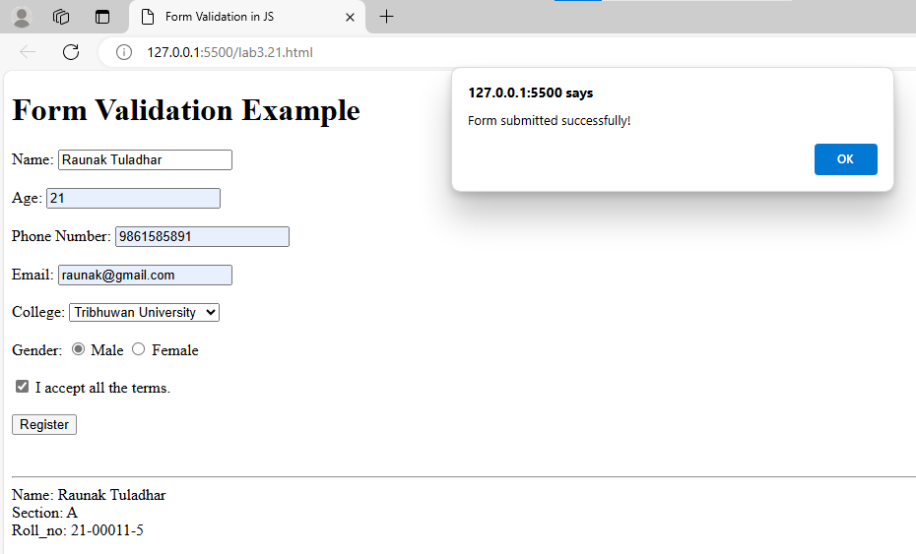

1. **Develop a form where validation occurs in real-time as the user types. Use events like keyup or input to trigger immediate feedback on the validity of the entered data.**

<!DOCTYPE html>

<html lang="en">

<head>

<meta charset="UTF-8">

<meta name="viewport" content="width=device-width, initial-scale=1.0">

<title>Real Time Form Validation</title>

<style>

.error_11 {

color: red;

}

.valid_11 {

color: green;

}

.feedback_11 {

margin-top: 5px;

}

</style>

</head>

<body>

<h1>Real-Time Form Validation</h1>

<form id="realTimeForm_11">

<label for="name_11">Name:</label>

<input type="text" id="name_11" name="name_11">

<p id="nameFeedback_11" class="feedback_11"></p><br>

<label for="age_11">Age:</label>

<input type="number" id="age_11" name="age_11">

<p id="ageFeedback_11" class="feedback_11"></p><br>

<label for="phone_11">Phone Number:</label>

<input type="text" id="phone_11" name="phone_11">

<p id="phoneFeedback_11" class="feedback_11"></p><br>

<label for="email_11">Email:</label>

<input type="email" id="email_11" name="email_11">

<p id="emailFeedback_11" class="feedback_11"></p><br>

<input type="submit" value="Submit">

</form>

<script>

function validateName_11() {

let name_11 = document.getElementById('name_11').value.trim();

let nameFeedback_11 = document.getElementById('nameFeedback_11');

let namePattern_11 = /^[a-zA-Z\s]{7,}$/;

if (!name_11) {

nameFeedback_11.textContent = 'Name is required.';

nameFeedback_11.className = 'feedback_11 error_11';

} else if (!namePattern_11.test(name_11)) {

nameFeedback_11.textContent = 'Name must be at least 7 characters long and contain only alphabets and spaces.';

nameFeedback_11.className = 'feedback_11 error_11';

} else {

nameFeedback_11.textContent = 'Name is valid.';

nameFeedback_11.className = 'feedback_11 valid_11';

}

}

function validateAge_11() {

let age_11 = document.getElementById('age_11').value.trim();

let ageFeedback_11 = document.getElementById('ageFeedback_11');

if (!age_11 || isNaN(age_11) || age_11 < 1 || age_11 > 50) {

ageFeedback_11.textContent = 'Age must be an integer between 1 and 50.';

ageFeedback_11.className = 'feedback_11 error_11';

} else {

ageFeedback_11.textContent = 'Age is valid.';

ageFeedback_11.className = 'feedback_11 valid_11';

}

}

function validatePhone_11() {

let phone_11 = document.getElementById('phone_11').value.trim();

let phoneFeedback_11 = document.getElementById('phoneFeedback_11');

let phonePattern_11 = /^(98|97)\d{8}$/;

if (!phone_11 || !phonePattern_11.test(phone_11)) {

phoneFeedback_11.textContent = 'Phone number must be exactly 10 digits long and start with 98 or 97.';

phoneFeedback_11.className = 'feedback_11 error_11';

} else {

phoneFeedback_11.textContent = 'Phone number is valid.';

phoneFeedback_11.className = 'feedback_11 valid_11';

}

}

function validateEmail_11() {

let email_11 = document.getElementById('email_11').value.trim();

let emailFeedback_11 = document.getElementById('emailFeedback_11');

let emailPattern_11 = /^[a-zA-Z0-9._-]+@[a-zA-Z0-9.-]+\.[a-zA-Z]{2,6}$/;

if (!email_11 || !emailPattern_11.test(email_11)) {

emailFeedback_11.textContent = 'Please enter a valid email address.';

emailFeedback_11.className = 'feedback_11 error_11';

} else {

emailFeedback_11.textContent = 'Email is valid.';

emailFeedback_11.className = 'feedback_11 valid_11';

}

}

document.getElementById('name_11').addEventListener('input', validateName_11);

document.getElementById('age_11').addEventListener('input', validateAge_11);

document.getElementById('phone_11').addEventListener('input', validatePhone_11);

document.getElementById('email_11').addEventListener('input', validateEmail_11);

</script>

<br>

<hr>

<footer>

Name: Raunak Tuladhar <br>

Section: A <br>

Roll_no: 21-00011-5

</footer>

</body>

</html>

**Output:**

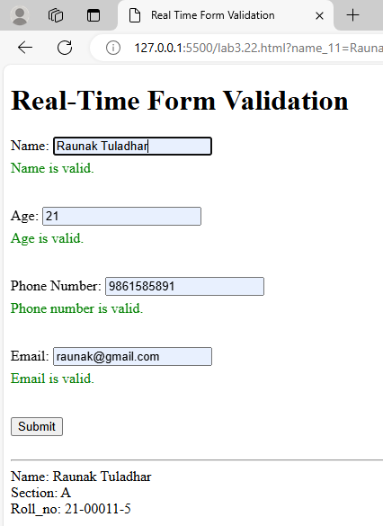

**23. Design a form with conditional validation. For example, validate a postal code only if a specific country is selected. Implement this logic using JavaScript and jQuery.**

<!DOCTYPE html>

<html lang="en">

<head>

<meta charset="UTF-8">

<meta name="viewport" content="width=device-width, initial-scale=1.0">

<title>Conditional Validation Form</title>

<style>

.error_11 {

color: red;

}

.valid_11 {

color: green;

}

.feedback_11 {

margin-top: 5px;

}

</style>

<script src="https://code.jquery.com/jquery-3.6.0.min.js"></script>

</head>

<body>

<h1>Conditional Validation Form</h1>

<form id="conditionalForm_11">

<label for="country_11">Country:</label>

<select id="country_11" name="country_11">

<option value="">Select a country</option>

<option value="Nepal">Nepal</option>

<option value="India">India</option>

<option value="USA">USA</option>

</select><br><br>

<label for="postalCode_11">Postal Code:</label>

<input type="text" id="postalCode_11" name="postalCode_11">

<p id="postalCodeFeedback_11" class="feedback_11"></p><br>

<input type="submit" value="Submit">

</form>

<script>

$(document).ready(function () {

function validatePostalCode_11() {

let country_11 = $('#country_11').val();

let postalCode_11 = $('#postalCode_11').val().trim();

let postalCodeFeedback_11 = $('#postalCodeFeedback_11');

if (country_11 === 'Nepal') {

let postalCodePattern_11 = /^[0-9]{5}$/;

if (!postalCode_11 || !postalCodePattern_11.test(postalCode_11)) {

postalCodeFeedback_11.text('Postal code must be exactly 5 digits long.');

postalCodeFeedback_11.removeClass('valid_11').addClass('error_11');

} else {

postalCodeFeedback_11.text('Postal code is valid.');

postalCodeFeedback_11.removeClass('error_11').addClass('valid_11');

}

} else {

postalCodeFeedback_11.text('Postal code is not required for this country.');

postalCodeFeedback_11.removeClass('error_11 valid_11');

}

}

$('#country_11').change(validatePostalCode_11);

$('#postalCode_11').on('input', validatePostalCode_11);

$('#conditionalForm_11').on('submit', function (event) {

let country_11 = $('#country_11').val();

let postalCodeFeedback_11 = $('#postalCodeFeedback_11');

if (country_11 === 'Nepal') {

let postalCode_11 = $('#postalCode_11').val().trim();

let postalCodePattern_11 = /^[0-9]{5}$/;

if (!postalCode_11 || !postalCodePattern_11.test(postalCode_11)) {

postalCodeFeedback_11.text('Postal code must be exactly 5 digits long.');

postalCodeFeedback_11.removeClass('valid_11').addClass('error_11');

event.preventDefault();

}

}

});

});

</script>

<br>

<hr>

<footer>

Name: Raunak Tuladhar <br>

Section: A <br>

Roll_no: 21-00011-5

</body>

</html>

**Output:**

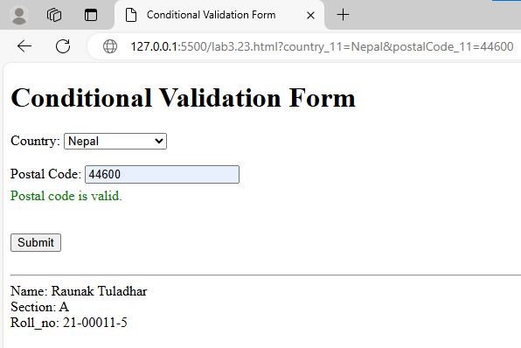

**Lab 4: PHP**

1. **Write a simple PHP script that prints "Hello, PHP!" to the browser.**

<?php

echo "Hello, PHP!"."<br>";

echo "<br>"."<hr>";

echo "Name: Raunak Tuladhar"."<br>";

echo "Section: A"."<br>";

echo "Roll_no: 21-00011-5";

?>

**Output:**

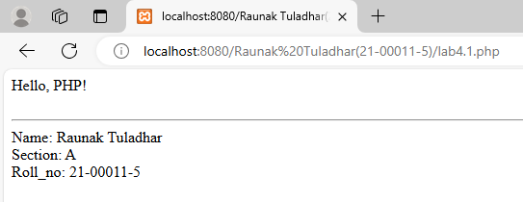

1. **Declare variables of different data types (integer, float, string) and demonstrate the usage of constants in PHP.**

<?php

$intValue_11 = 5;

$floatValue_11 = 5.5;

$stringValue_11 = "Raunak";

define("PI_CONSTANT_11", 3.14159);

define("GREETING_CONSTANT_11", "Welcome to PHP!");

echo "Integer Variable: $intValue_11<br>";

echo "Float Variable: $floatValue_11<br>";

echo "String Variable: $stringValue_11<br>";

echo "PI Constant: " . PI_CONSTANT_11 . "<br>";

echo "Greeting Constant: " . GREETING_CONSTANT_11 . "<br>";

echo "<br>"."<hr>";

echo "Name: Raunak Tuladhar"."<br>";

echo "Section: A"."<br>";

echo "Roll_no: 21-00011-5";

?>

**Output:**

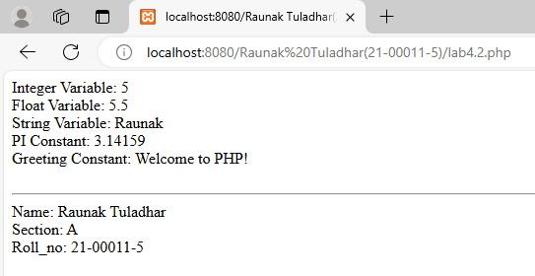

1. **Create a PHP program that uses if-else statements to check if a number is positive, negative, or zero. Utilize different operators for comparison.**

<?php

$num_11 = 5;

if($num_11 > 0){

echo "The number $num_11 is Positive";

}

elseif($num_11 < 0){

echo "The number $num_11 is Negative";

}

else{

echo "The number $num_11 is Zero";

}

echo "<br>"."<hr>";

echo "Name: Raunak Tuladhar"."<br>";

echo "Section: A"."<br>";

echo "Roll_no: 21-00011-5";

?>

**Output:**

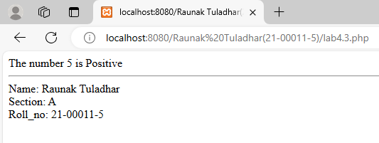

1. **Develop a function that calculates the average of an array of numbers. Test the function with various arrays.**

<?php

function calculateAverage_11($numArray_11) {

if (count($numArray_11) === 0) {

return 0;

}

$sum_11 = array_sum($numArray_11);

$count_11 = count($numArray_11);

return $sum_11 / $count_11;

}

$numArray1_11 = [1, 2, 3, 4, 5];

$numArray2_11 = [10, 20, 30, 40];

$numArray3_11 = [7, 14, 21, 28, 35];

echo "Average of array [1, 2, 3, 4, 5]: " . calculateAverage_11($numArray1_11) . "<br>";

echo "Average of array [10, 20, 30, 40]: " . calculateAverage_11($numArray2_11) . "<br>";

echo "Average of array [7, 14, 21, 28, 35]: " . calculateAverage_11($numArray3_11) . "<br>";

echo "<br>"."<hr>";

echo "Name: Raunak Tuladhar"."<br>";

echo "Section: A"."<br>";

echo "Roll_no: 21-00011-5";

?>

**Output:**

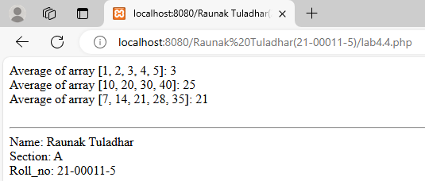

1. **Define a PHP class representing a "Book" with properties like title and author. Create objects of this class and display their attributes.**

<?php

class Book_11 {

public $title_11;

public $author_11;

public function __construct($title_11, $author_11) {

$this->title_11 = $title_11;

$this->author_11 = $author_11;

}

public function displayDetails_11() {

echo "Title: " . $this->title_11 . "<br>";

echo "Author: " . $this->author_11 . "<br>";

}

}

$book1_11 = new Book_11("1984", "George Orwell");

$book2_11 = new Book_11("To Kill a Mockingbird", "Harper Lee");

echo "<strong>Book 1:</strong><br>";

$book1_11->displayDetails_11();

echo "<br><strong>Book 2:</strong><br>";

$book2_11->displayDetails_11();

echo "<br>"."<hr>";

echo "Name: Raunak Tuladhar"."<br>";

echo "Section: A"."<br>";

echo "Roll_no: 21-00011-5";

?>

**Output:**

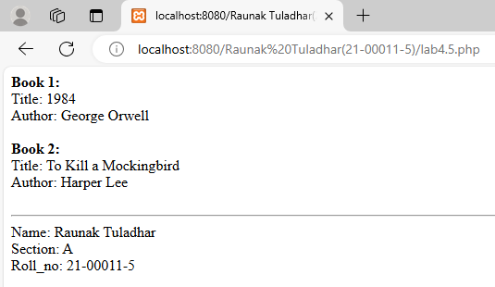

1. **Design a simple HTML form with input fields. Create a PHP script that retrieves and displays the form data when submitted.**

<?php

if ($_SERVER["REQUEST_METHOD"] == "POST") {

$name_11 = $_POST['name_11'];

$email_11 = $_POST['email_11'];

$message_11 = $_POST['message_11'];

echo "<h2>Form Data Submitted:</h2>";

echo "Name: " . $name_11 . "<br>";

echo "Email: " . $email_11 . "<br>";

echo "Message: " . $message_11 . "<br>";

}

?>

<html>

<head>

<title>HTML Form Data</title>

</head>

<body>

<h1>Contact Form</h1>

<form method="post" action="<?php echo $_SERVER["PHP_SELF"]; ?>">

<label for="name_11">Name:</label><br>

<input type="text" id="name_11" name="name_11" required><br><br>

<label for="email_11">Email:</label><br>

<input type="email" id="email_11" name="email_11" required><br><br>

<label for="message_11">Message:</label><br>

<textarea id="message_11" name="message_11" rows="4" cols="50" required></textarea><br><br>

<input type="submit" value="Submit">

</form>

<br>

<?php

echo "<br>"."<hr>";

echo "Name: Raunak Tuladhar"."<br>";

echo "Section: A"."<br>";

echo "Roll_no: 21-00011-5";

?>

</body>

</html>

**Output:**

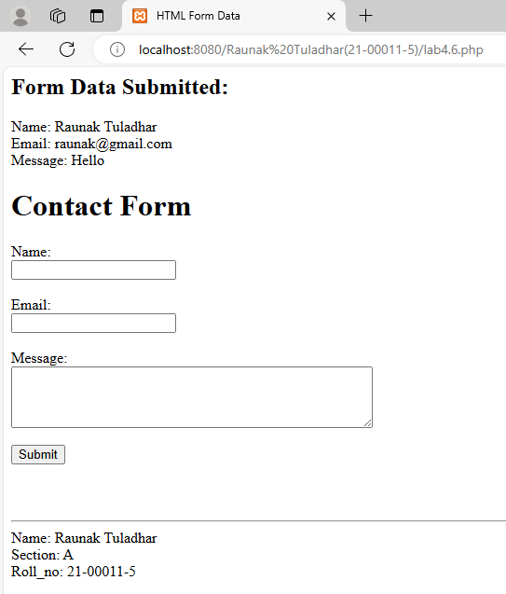\

1. **Enhance the previous form with PHP validation. Ensure that required fields are filled, and validate email addresses and make sure the phone number starts with 98 or 97 using regex.**

<?php

$nameError_11 = $emailError_11 = $phoneError_11 = $messageError_11 = "";

$name_11 = $email_11 = $phone_11 = $message_11 = "";

if ($_SERVER["REQUEST_METHOD"] == "POST") {

if (empty($_POST['name_11'])) {

$nameError_11 = "Name is required.";

} else {

$name_11 = $_POST['name_11'];

}

if (empty($_POST['email_11'])) {

$emailError_11 = "Email is required.";

} elseif (!filter_var($_POST['email_11'], FILTER_VALIDATE_EMAIL)) {

$emailError_11 = "Invalid email format.";

} else {

$email_11 = $_POST['email_11'];

}

if (empty($_POST['phone_11'])) {

$phoneError_11 = "Phone number is required.";

} elseif (!preg_match('/^(98|97)\d{8}$/', $_POST['phone_11'])) {

$phoneError_11 = "Phone number must start with 98 or 97 and be 10 digits long.";

} else {

$phone_11 = $_POST['phone_11'];

}

if (empty($_POST['message_11'])) {

$messageError_11 = "Message is required.";

} else {

$message_11 = $_POST['message_11'];

}

if (empty($nameError_11) && empty($emailError_11) && empty($phoneError_11) && empty($messageError_11)) {

echo "<h2>Form Data Submitted:</h2>";

echo "Name: " . $name_11 . "<br>";

echo "Email: " . $email_11 . "<br>";

echo "Phone: " . $phone_11 . "<br>";

echo "Message: " . $message_11 . "<br>";

}

}

?>

<html>

<head>

<title>Enhanced Contact Form</title>

</head>

<body>

<h1>Contact Form</h1>

<form method="post" action="<?php echo htmlspecialchars($_SERVER["PHP_SELF"]); ?>">

<label for="name_11">Name:</label><br>

<input type="text" id="name_11" name="name_11" value="<?php echo $name_11; ?>">

<span style="color: red;"><?php echo $nameError_11; ?></span><br><br>

<label for="email_11">Email:</label><br>

<input type="email" id="email_11" name="email_11" value="<?php echo $email_11; ?>">

<span style="color: red;"><?php echo $emailError_11; ?></span><br><br>

<label for="phone_11">Phone Number:</label><br>

<input type="text" id="phone_11" name="phone_11" value="<?php echo $phone_11; ?>">

<span style="color: red;"><?php echo $phoneError_11; ?></span><br><br>

<label for="message_11">Message:</label><br>

<textarea id="message_11" name="message_11" rows="4" cols="50"><?php echo $message_11; ?></textarea>

<span style="color: red;"><?php echo $messageError_11; ?></span><br><br>

<input type="submit" value="Submit">

</form>

<br>

<?php

echo "<br>"."<hr>";

echo "Name: Raunak Tuladhar"."<br>";

echo "Section: A"."<br>";

echo "Roll_no: 21-00011-5";

?>

</body>

</html>

**Output:**

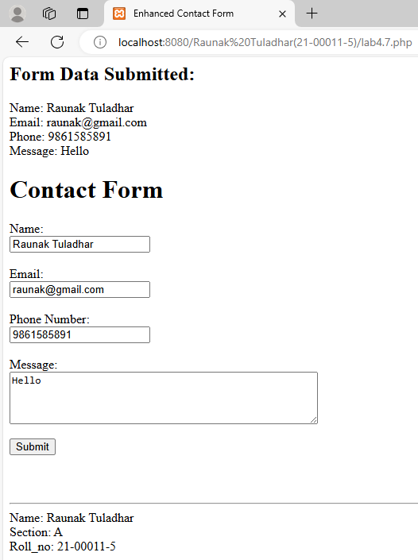

1. **Implement PHP code that responds to a button click event on a form. Display a message when the button is clicked.**

<?php

$buttonMessage_11 = "";

if ($_SERVER["REQUEST_METHOD"] == "POST") {

if (isset($_POST['clickButton_11'])) {

$buttonMessage_11 = "Button was clicked!";

}

}

?>

<html>

<head>

<title>Button Click </title>

</head>

<body>

<h1>Button Click</h1>

<form method="post" action="<?php echo htmlspecialchars($_SERVER["PHP_SELF"]); ?>">

<input type="submit" name="clickButton_11" value="Click Me">

</form>

<?php

if (!empty($buttonMessage_11)) {

echo "<h2>$buttonMessage_11</h2>";

}

?>

<br>

<?php

echo "<br>"."<hr>";

echo "Name: Raunak Tuladhar"."<br>";

echo "Section: A"."<br>";

echo "Roll_no: 21-00011-5";

?>

</body>

</html>

**Output:**

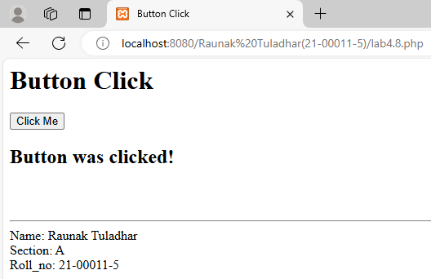

1. **Create a PHP script that sets a cookie with user preferences. Retrieve and display this information on subsequent visits.**

<?php

$cookieName_11 = "userName_11";

$cookieExpiry_11 = time() + (86400 * 7);

$userName_11 = $storedUserName_11 = "";

if ($_SERVER["REQUEST_METHOD"] == "POST") {

$userName_11 = trim($_POST['userName_11']);

setcookie($cookieName_11, $userName_11, $cookieExpiry_11, "/");

header("Location: " . $_SERVER['PHP_SELF']);

exit();

}

if (isset($_COOKIE[$cookieName_11])) {

$storedUserName_11 = $_COOKIE[$cookieName_11];

}

?>

<html>

<head>

<title>Cookie</title>

</head>

<body>

<h1>Set Your Name</h1>

<form method="post" action="<?php echo $_SERVER["PHP_SELF"]; ?>">

<label for="userName_11">Enter your name:</label><br>

<input type="text" id="userName_11" name="userName_11" value="<?php echo $userName_11; ?>" required><br><br>

<input type="submit" value="Save Name">

</form>

<?php

if (!empty($storedUserName_11)) {

echo "<h2>Welcome back, " . $storedUserName_11 . "!</h2>";

}

?>

<br>

<?php

echo "<br>"."<hr>";

echo "Name: Raunak Tuladhar"."<br>";

echo "Section: A"."<br>";

echo "Roll_no: 21-00011-5";

?>

</body>

</html>

**Output:**

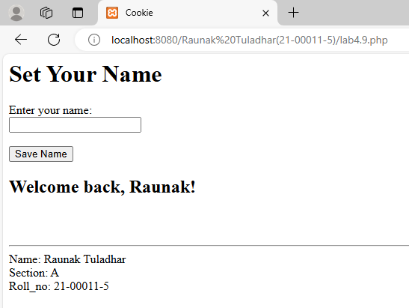

1. **Develop a PHP script that reads content from a text file, modifies it, and then writes the updated content back to the file.**

<?php

$filePath_11 = "raunak.txt";

$originalContent_11 = $modifiedContent_11 = "";

if (file_exists($filePath_11)) {

$originalContent_11 = file_get_contents($filePath_11);

$modifiedContent_11 = $originalContent_11 . "\nThis line was added by the PHP script.";

file_put_contents($filePath_11, $modifiedContent_11);

$updatedContent_11 = file_get_contents($filePath_11);

} else {

$originalContent_11 = "The file does not exist.";

$updatedContent_11 = $originalContent_11;

}

?>

<html>

<head>

<title>File Content</title>

</head>

<body>

<h2>Original Content:</h2>

<pre><?php echo htmlspecialchars($originalContent_11); ?></pre>

<h2>Updated Content:</h2>

<pre><?php echo htmlspecialchars($updatedContent_11); ?></pre>

<br>

<?php

echo "<br>"."<hr>";

echo "Name: Raunak Tuladhar"."<br>";

echo "Section: A"."<br>";

echo "Roll_no: 21-00011-5";

?>

</body>

</html>

**Output:**

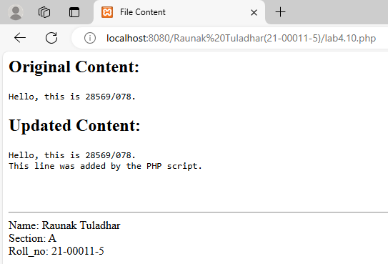

**Connecting to Database**

**1. Write PHP code to establish a connection to a MySQL database, including the necessary credentials.**

**2. Develop a PHP script to insert a new record into a MySQL database table. Ensure proper validation and sanitation of input data.**

**3. Create a PHP script that retrieves and displays all records from a MySQL database table.**

**4. Modify a specific record in a MySQL table using PHP. Ensure that the update is based on user input or specific criteria.**

**5. Implement PHP code to delete a record from a MySQL table. Provide options for the user to select the record to be deleted.**

**database.php:**

<?php

$conn_11 = mysqli_connect('localhost:3307', 'root', '', 'studentdb_28569');

if(!$conn_11){

die("Connection failed: ".mysqli_connect_error());

}

?>

**insert.php:**

<?php

include 'database.php';

function validate_input($pattern_11, $input_11) {

return preg_match($pattern_11, $input_11);

}

if ($_SERVER["REQUEST_METHOD"] == "POST") {

$name_11 = $_POST['name_11'];

$roll_11 = $_POST['roll_11'];

$email_11 = $_POST['email_11'];

$contact_11 = $_POST['contact_11'];

$name_pattern_11 = "/^[a-zA-Z\s]+$/";

$roll_pattern_11 = "/^\d+$/";

$email_pattern_11 = "/^[a-zA-Z0-9._%+-]+@[a-zA-Z0-9.-]+\.[a-zA-Z]{2,}$/";

$contact_pattern_11 = "/^\d{10}$/";

$errors_11 = [];

if (!validate_input($name_pattern_11, $name_11)) {

$errors_11[] = "Invalid name format. Name should only contain letters and spaces.";

}

if (!validate_input($roll_pattern_11, $roll_11)) {

$errors_11[] = "Invalid roll format. Roll number should be numeric.";

}

if (!validate_input($email_pattern_11, $email_11)) {

$errors_11[] = "Invalid email format. Please enter a valid email address.";

}

if (!validate_input($contact_pattern_11, $contact_11)) {

$errors_11[] = "Invalid contact format. Contact number should be exactly 10 digits.";

}

if (count($errors_11) > 0) {

foreach ($errors_11 as $error_11) {

echo "<p style='color: red;'>$error_11</p>";

}

} else {

$name_11 = mysqli_real_escape_string($conn_11, $name_11);

$roll_11 = mysqli_real_escape_string($conn_11, $roll_11);

$email_11 = mysqli_real_escape_string($conn_11, $email_11);

$contact_11 = mysqli_real_escape_string($conn_11, $contact_11);

$sql_11 = "INSERT INTO students_28569 (Name, Roll, Email, Contact) VALUES ('$name_11', '$roll_11', '$email_11',

'$contact_11')";

if (mysqli_query($conn_11, $sql_11)) {

echo "<p style='color: green;'>New record created successfully.</p>";

} else {

echo "<p style='color: red;'>Error: " . mysqli_error($conn_11) . "</p>";

}

}

}

?>

<h3>Insert Records </h3><br>

<form action="insert.php" method="post">

Name: <input type="text" name="name_11" required><br><br>

Roll: <input type="text" name="roll_11" required><br><br>

Email: <input type="email" name="email_11" required><br><br>

Contact: <input type="text" name="contact_11" required><br><br>

<input type="submit" value="Insert">

</form>

<a href="index.php">Back to Home</a>

**display.php:**

<?php

include 'database.php';

$sql_11 = "SELECT * FROM students_28569";

$result_11 = mysqli_query($conn_11, $sql_11);

echo "<table border='1' cellspacing='0' cellpadding='2'>

<tr>

<th>ID</th>

<th>Name</th>

<th>Roll</th>

<th>Email</th>

<th>Contact</th>

<th>Actions</th>

</tr>";

while($row_11 = mysqli_fetch_assoc($result_11)) {

echo "<tr>";

echo "<td>" . $row_11['id'] . "</td>";

echo "<td>" . $row_11['Name'] . "</td>";

echo "<td>" . $row_11['Roll'] . "</td>";

echo "<td>" . $row_11['Email'] . "</td>";

echo "<td>" . $row_11['Contact'] . "</td>";

echo "<td><a href='edit.php?id=" . $row_11['id'] . "'>Edit</a> | <a href='delete.php?id=" . $row_11['id'] .

"'>Delete</a></td>";

echo "</tr>";

}

echo "</table>";

mysqli_close($conn_11);

?>

**edit.php:**

<?php

include 'database.php';

function validate_input($pattern_11, $input_11) {

return preg_match($pattern_11, $input_11);

}

if ($_SERVER["REQUEST_METHOD"] == "POST") {

$id_11 = intval($_POST['id_11']);

$name_11 = $_POST['name_11'];

$roll_11 = $_POST['roll_11'];

$email_11 = $_POST['email_11'];

$contact_11 = $_POST['contact_11'];

$name_pattern_11 = "/^[a-zA-Z\s]+$/";

$roll_pattern_11 = "/^\d+$/";

$email_pattern_11 = "/^[a-zA-Z0-9._%+-]+@[a-zA-Z0-9.-]+\.[a-zA-Z]{2,}$/";

$contact_pattern_11 = "/^\d{10}$/";

$errors_11 = [];

if (!validate_input($name_pattern_11, $name_11)) {

$errors_11[] = "Invalid name format. Name should only contain letters and spaces.";

}

if (!validate_input($roll_pattern_11, $roll_11)) {

$errors_11[] = "Invalid roll format. Roll number should be numeric.";

}

if (!validate_input($email_pattern_11, $email_11)) {

$errors_11[] = "Invalid email format. Please enter a valid email address.";

}

if (!validate_input($contact_pattern_11, $contact_11)) {

$errors_11[] = "Invalid contact format. Contact number should be exactly 10 digits.";

}

if (count($errors_11) > 0) {

foreach ($errors_11 as $error_11) {

echo "<p style='color: red;'>$error_11</p>";

}

} else {

$name_11 = mysqli_real_escape_string($conn_11, $name_11);

$roll_11 = mysqli_real_escape_string($conn_11, $roll_11);

$email_11 = mysqli_real_escape_string($conn_11, $email_11);

$contact_11 = mysqli_real_escape_string($conn_11, $contact_11);

$sql_11 = "UPDATE students_28569 SET Name='$name_11', Roll='$roll_11', Email='$email_11',

Contact='$contact_11' WHERE id=$id_11";

if (mysqli_query($conn_11, $sql_11)) {

echo "<p style='color: green;'>Record updated successfully.</p>";

} else {

echo "<p style='color: red;'>Error: " . mysqli_error($conn_11) . "</p>";

}

}

} else {

$id_11 = intval($_GET['id']);

if ($id_11 > 0) {

$sql_11 = "SELECT * FROM students_28569 WHERE id=$id_11";

$result_11 = mysqli_query($conn_11, $sql_11);

if (mysqli_num_rows($result_11) > 0) {

$row_11 = mysqli_fetch_assoc($result_11);

} else {

echo "<p style='color: red;'>Record not found.</p>";

$row_11 = null;

}

} else {

echo "<p style='color: red;'>Invalid ID.</p>";

$row_11 = null;

}

}

?>

<?php if (isset($row_11) && $row_11 !== null): ?>

<h3>Edit Records </h3><br>

<form action="edit_record.php" method="post">

<input type="hidden" name="id_11" value="<?php echo htmlspecialchars($row_11['id']); ?>">

Name: <input type="text" name="name_11" value="<?php echo htmlspecialchars($row_11['Name']); ?>"

required><br><br>

Roll: <input type="text" name="roll_11" value="<?php echo htmlspecialchars($row_11['Roll']); ?>" required><br><br>

Email: <input type="email" name="email_11" value="<?php echo htmlspecialchars($row_11['Email']); ?>"

required><br><br>

Contact: <input type="text" name="contact_11" value="<?php echo htmlspecialchars($row_11['Contact']); ?>"

required><br><br>

<input type="submit" value="Update">

</form>

<?php else: ?>

<p>No record available for editing.</p>

<?php endif; ?>

<a href="index.php">Back to Home</a>

**delete.php:**

<?php

include 'database.php';

$id_11 = intval($_GET['id']);

$sql_11 = "DELETE FROM students_28569 WHERE id=$id_11";

if (mysqli_query($conn_11, $sql_11)) {

echo "Record deleted successfully.";

} else {

echo "Error: " . $sql_11 . "<br>" . mysqli_error($conn_11);

}

mysqli_close($conn_11);

?>

<a href="index.php">Back to Home</a>

**index.php:**

<h2>Student Records</h2>

<a href="insert.php">Insert New Record</a> <br> <br>

<?php

include 'display.php';

?>

**Output:**

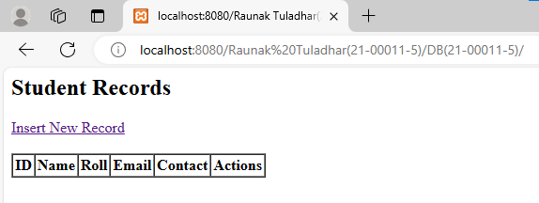

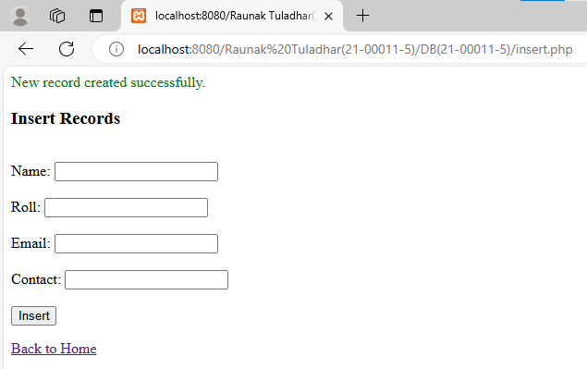

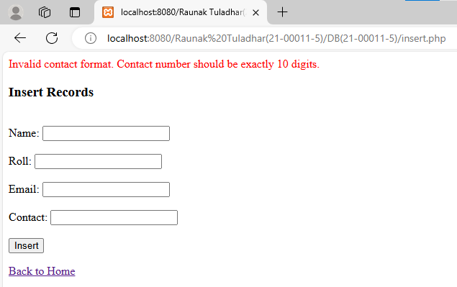

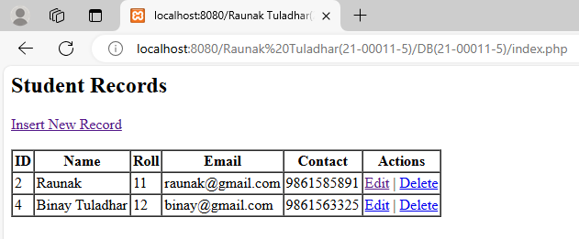

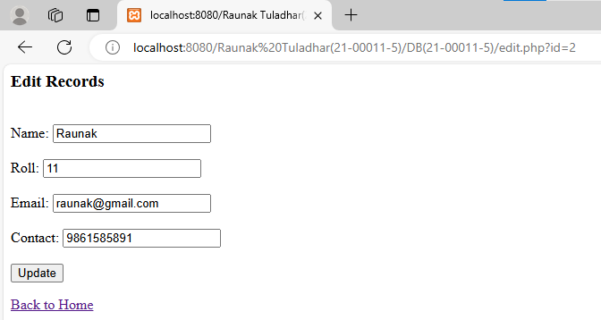

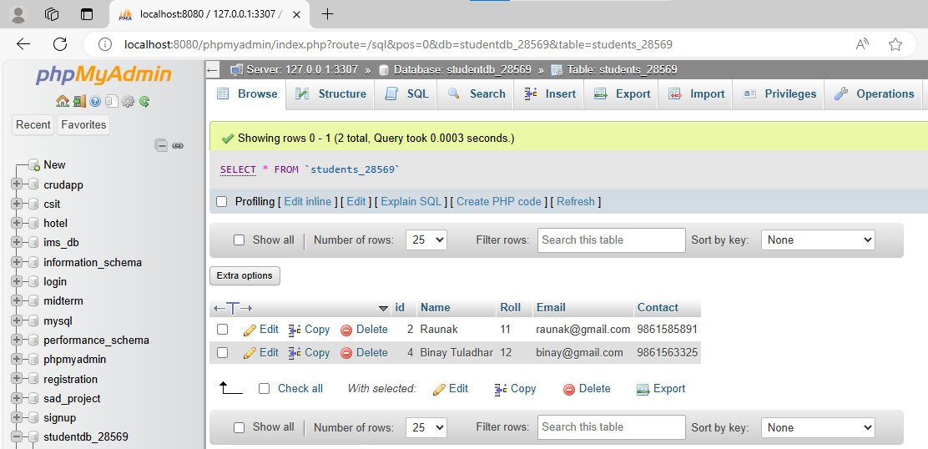

**Lab 5: Ajax and XML**

1. **Develop a simple HTML page with a button. Implement AJAX to make a request to a server-side script (e.g., PHP or Python) when the button is clicked. Display the response on the webpage without refreshing.**

**HTML:**

<!DOCTYPE html>

<html lang="en">

<head>

<meta charset="UTF-8">

<meta name="viewport" content="width=device-width, initial-scale=1.0">

<title>Message from server without refreshing</title>

<script>

function sendRequest() {

let xhr = new XMLHttpRequest();

xhr.open("GET", "lab5.1.php", true);

xhr.onload = function () {

if (xhr.status === 200) {

document.getElementById("response").innerText = xhr.responseText;

}

else {

document.getElementById("response").innerText = "Error: " + xhr.status;

}

};

xhr.send();

}

</script>

</head>

<body>

<h2>Send Request to Server</h2>

<button onclick="sendRequest()">Send</button>

<div id="response" style="margin-top: 15px;"></div>

<br>

<hr>

<footer>

Name: Raunak Tuladhar <br>

Section: A <br>

Roll_no: 21-00011-5

</footer>

</body>

</html>

**PHP:**

<?php

echo "Hello from the server!";

?>

**Output:**

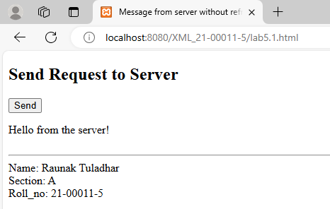

1. **Create a simple XML element.**

<?xml version = "1.0"?>

<student>

<name>Raunak Tuladhar</name>

<roll>21-00011-5</roll>

</student>

**Output:**

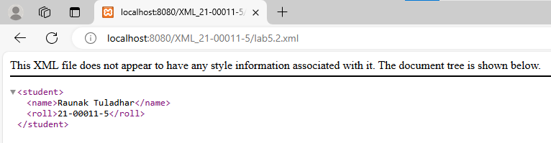

1. **Create a XML document with simple and complex type.**

<?xml version = "1.0"?>

<subjects>

<subject>

<name>English</name>

<name>Science

<type>Physics</type>

<type>Chemistry</type>

<type>Biology</type>

</name>

</subject>

</subjects>

**Output:**

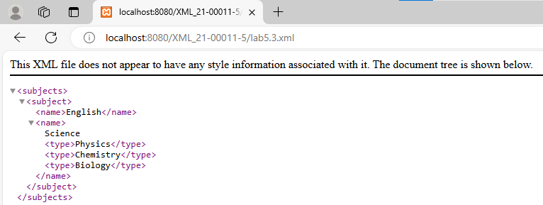

1. **Create an XML document that conforms to the following DTD.**

**<?xml version="1.0" encoding="UTF-8"?>**

**<!ELEMENT Report (Students, Classes, Courses)>**

**<!ELEMENT Students (Student*)>**

**<!ELEMENT Classes (Class*)>**

**<!ELEMENT Courses (Course*)>**

**<!ELEMENT Student (Name, Status, CrsTaken*)>**

**<!ELEMENT Name (First, Last)>**

**<!ELEMENT First (#PCDATA)>**

**<!ELEMENT Last (#PCDATA)>**

**<!ELEMENT Status (#PCDATA)>**

**<!ELEMENT CrsTaken (#PCDATA)>**

**<!ELEMENT Class (Semester, ClassRoster)>**

**<!ELEMENT Semester (#PCDATA)>**

**<!ELEMENT ClassRoster (#PCDATA)>**

**<!ELEMENT Course (#PCDATA)>**

**<!ATTLIST Student StudId ID #REQUIRED>**

**<!ATTLIST Course CrsCode ID #REQUIRED>**

**<!ATTLIST CrsTaken CrsCode IDREF #REQUIRED>**

**<!ATTLIST ClassRoster Members IDREFS #REQUIRED>**

<?xml version = "1.0" encoding = "UTF-8"?>

<report>

<students>

<student sid='S1'>

<name>

<first>Raunak</first>

<last>Tuladhar</last>

</name>

<status>Active</status>

<crstaken cid='C1'>Mathematics-I</crstaken>

<crstaken cid='C2'>Discrete Structure</crstaken>

</student>

</students>

<classes>

<class>

<semester>Batch 2078</semester>

<classroster crm="CR7">Ram, Shyam, Hari</classroster>

</class>

</classes>

<courses>

<course cid='C1'>Mathematics-I</course>

<course cid='C2'>Discrete Structure</course>

</courses>

</report>

**Output:**

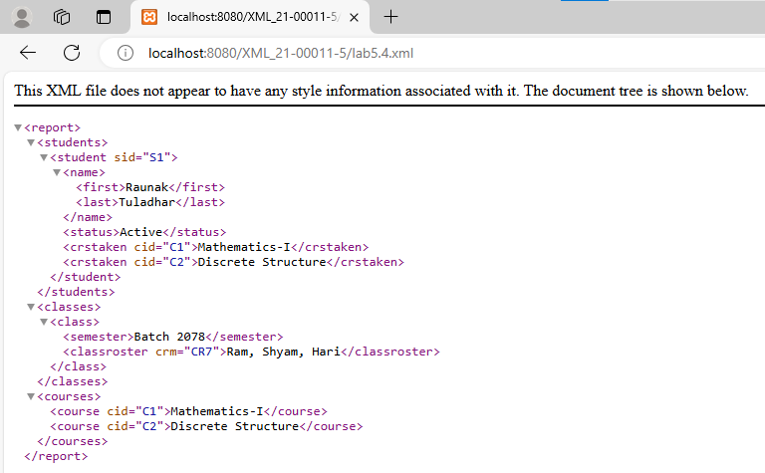

1. **Create an HTML form that collects user information (e.g., name, email). Use JavaScript to dynamically generate an XML document based on the form data when the user submits the form.**

<!DOCTYPE html>

<html lang="en">

<head>

<meta charset="UTF-8">

<meta name="viewport" content="width=device-width, initial-scale=1.0">

<title>XML from user information</title>

<script>

function generateXML_11() {

event.preventDefault();

let name_11 = document.getElementById('name_11').value;

let email_11 = document.getElementById('email_11').value;

let xml_11 = '<?xml version="1.0" encoding="UTF-8"?>\n';

xml_11 += '<UserInfo>\n';

xml_11 += ' <Name>' + escapeXml_11(name_11) + '</Name>\n';

xml_11 += ' <Email>' + escapeXml_11(email_11) + '</Email>\n';

xml_11 += '</UserInfo>';

document.getElementById('xmlOutput_11').textContent = xml_11;

}

function escapeXml_11(unsafe_11) {

return unsafe_11.replace(/[<>&'"]/g, function (c) {

switch (c) {

case '<': return '&lt;';

case '>': return '&gt;';

case '&': return '&amp;';

case '\'': return '&#039;';

case '"': return '&quot;';

}

});

}

</script>

</head>

<body>

<h1>User Information</h1>

<form id="userForm_11" onsubmit="generateXML_11()">

<label for="name_11">Name:</label>

<input type="text" id="name_11" name="name_11" required><br><br>

<label for="email_11">Email:</label>

<input type="email" id="email_11" name="email_11" required><br><br>

<input type="submit" value="Generate XML">

</form>

<h2>Generated XML:</h2>

<pre id="xmlOutput_11"></pre>

<br>

<hr>

<footer>

Name: Raunak Tuladhar <br>

Section: A <br>

Roll_no: 21-00011-5

</footer>

</body>

</html>

**Output:**

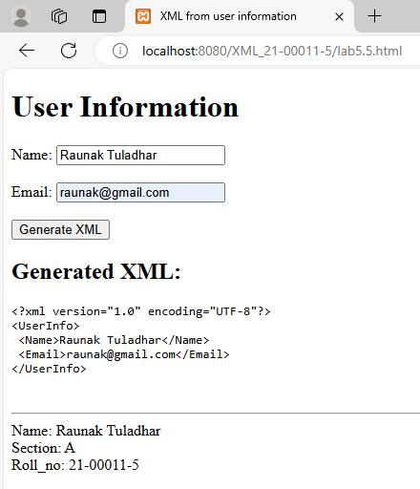

1. **Construct an XML tree with various elements and attributes. Use JavaScript to manipulate the tree dynamically, adding new elements, modifying attributes, or removing existing elements.**

<!DOCTYPE html>

<html lang="en">

<head>

<meta charset="UTF-8">

<meta name="viewport" content="width=device-width, initial-scale=1.0">

<title>XML tree manipulation</title>

<script>

let xmlDoc_11;

function initializeXML_11() {

let xmlString_11 = '<?xml version="1.0" encoding="UTF-8"?>\n';

xmlString_11 += '<Library>\n';

xmlString_11 += ' <Book id="B001" genre="Fiction">\n';

xmlString_11 += ' <Title>Book One</Title>\n';

xmlString_11 += ' <Author>Author One</Author>\n';

xmlString_11 += ' </Book>\n';

xmlString_11 += ' <Book id="B002" genre="Non-Fiction">\n';

xmlString_11 += ' <Title>Book Two</Title>\n';

xmlString_11 += ' <Author>Author Two</Author>\n';

xmlString_11 += ' </Book>\n';

xmlString_11 += '</Library>';

let parser_11 = new DOMParser();

xmlDoc_11 = parser_11.parseFromString(xmlString_11, 'text/xml');

}

function displayXML_11(xmlDoc_11, elementId_11) {

let serializer_11 = new XMLSerializer();

let xmlString_11 = serializer_11.serializeToString(xmlDoc_11);

document.getElementById(elementId_11).textContent = xmlString_11;

}

function modifyXML_11() {

let action_11 = document.querySelector('input[name="action_11"]:checked').value;

if (action_11 === 'add') {

let newBook_11 = xmlDoc_11.createElement('Book');

newBook_11.setAttribute('id', 'B003');

newBook_11.setAttribute('genre', 'Science Fiction');

let title_11 = xmlDoc_11.createElement('Title');

title_11.textContent = document.getElementById('newTitle_11').value;

newBook_11.appendChild(title_11);

let author_11 = xmlDoc_11.createElement('Author');

author_11.textContent = document.getElementById('newAuthor_11').value;

newBook_11.appendChild(author_11);

xmlDoc_11.documentElement.appendChild(newBook_11);

} else if (action_11 === 'modify') {

let bookId_11 = document.getElementById('modifyId_11').value;

let newGenre_11 = document.getElementById('newGenre_11').value;

let bookToModify_11 = xmlDoc_11.querySelector('Book[id="' + bookId_11 + '"]');

if (bookToModify_11) {

bookToModify_11.setAttribute('genre', newGenre_11);

}

} else if (action_11 === 'remove') {

let bookIdToRemove_11 = document.getElementById('removeId_11').value;

let bookToRemove_11 = xmlDoc_11.querySelector('Book[id="' + bookIdToRemove_11 + '"]');

if (bookToRemove_11) {

bookToRemove_11.parentNode.removeChild(bookToRemove_11);

}

}

displayXML_11(xmlDoc_11, 'modifiedXML_11');

}

</script>

</head>

<body onload="initializeXML_11()">

<h1>Simple XML Tree Manipulation</h1>

<h2>Original XML</h2>

<pre id="originalXML_11"></pre>

<h2>Select Modification</h2>

<form id="modificationForm_11">

<label>

<input type="radio" name="action_11" value="add" required>Add a new book

</label><br>

<label>

<input type="radio" name="action_11" value="modify">Modify an existing book

</label><br>

<label>

<input type="radio" name="action_11" value="remove">Remove a book

</label><br><br>

<div id="addFields_11" style="display: none;">

<label for="newTitle_11">Title:</label>

<input type="text" id="newTitle_11" name="newTitle_11"><br><br>

<label for="newAuthor_11">Author:</label>

<input type="text" id="newAuthor_11" name="newAuthor_11"><br><br>

</div>

<div id="modifyFields_11" style="display: none;">

<label for="modifyId_11">Book ID to Modify:</label>

<input type="text" id="modifyId_11" name="modifyId_11"><br><br>

<label for="newGenre_11">New Genre:</label>

<input type="text" id="newGenre_11" name="newGenre_11"><br><br>

</div>

<div id="removeFields_11" style="display: none;">

<label for="removeId_11">Book ID to Remove:</label>

<input type="text" id="removeId_11" name="removeId_11"><br><br>

</div>

<input type="button" value="Apply Modification" onclick="modifyXML_11()">

</form>

<h2>Modified XML:</h2>

<pre id="modifiedXML_11"></pre>

<script>

document.querySelectorAll('input[name="action_11"]').forEach(function (radio_11) {

radio_11.addEventListener('change', function () {

document.getElementById('addFields_11').style.display = this.value === 'add' ? 'block' : 'none';

document.getElementById('modifyFields_11').style.display = this.value === 'modify' ? 'block' : 'none';

document.getElementById('removeFields_11').style.display = this.value === 'remove' ? 'block' : 'none';

});

});

</script>

<br>

<hr>

<footer>

Name: Raunak Tuladhar <br>

Section: A <br>

Roll_no: 21-00011-5

</footer>

</body>

</html>

**Output:**

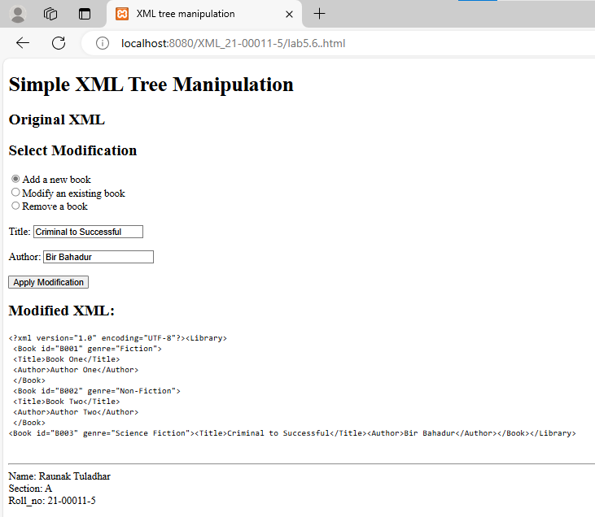

1. **Write an XML document representing a list of products. Create an XSLT stylesheet to transform the XML data into an HTML table format. Apply the transformation using JavaScript.**

**HTML:**

<!DOCTYPE html>

<html lang="en">

<head>

<meta charset="UTF-8">

<meta name="viewport" content="width=device-width, initial-scale=1.0">

<title>XML to HTML Transformation</title>

<script>

function transformXML_11() {

const xmlString_11 = `<?xml version="1.0" encoding="UTF-8"?>

<Products>

<Product id="P001">

<Name>Product One</Name>

<Price>$10.00</Price>

<Category>Electronics</Category>

</Product>

<Product id="P002">

<Name>Product Two</Name>

<Price>$20.00</Price>

<Category>Books</Category>

</Product>

<Product id="P003">

<Name>Product Three</Name>

<Price>$15.00</Price>

<Category>Clothing</Category>

</Product>

</Products>`;

const xsltString_11 = `<?xml version="1.0" encoding="UTF-8"?>

<xsl:stylesheet version="1.0"

xmlns:xsl="http://www.w3.org/1999/XSL/Transform">

<xsl:output method="html" indent="yes"/>

<xsl:template match="/">

<html>

<head>

<title>Product List</title>

</head>

<body>

<h1>Product List</h1>

<table border="1">

<tr>

<th>ID</th>

<th>Name</th>

<th>Price</th>

<th>Category</th>

</tr>

<xsl:for-each select="Products/Product">

<tr>

<td><xsl:value-of select="@id"/></td>

<td><xsl:value-of select="Name"/></td>

<td><xsl:value-of select="Price"/></td>

<td><xsl:value-of select="Category"/></td>

</tr>

</xsl:for-each>

</table>

</body>

</html>

</xsl:template>

</xsl:stylesheet>`;

const parser_11 = new DOMParser();

const xmlDoc_11 = parser_11.parseFromString(xmlString_11, 'text/xml');

const xsltDoc_11 = parser_11.parseFromString(xsltString_11, 'text/xml');

const xsltProcessor_11 = new XSLTProcessor();

xsltProcessor_11.importStylesheet(xsltDoc_11);

const resultDocument_11 = xsltProcessor_11.transformToFragment(xmlDoc_11, document);

document.getElementById('result_11').appendChild(resultDocument_11);

}

</script>

</head>

<body onload="transformXML_11()">

<h1>XML to HTML Transformation</h1>

<div id="result_11"></div>

</head>

<body>

<br>

<hr>

<footer>

Name: Raunak Tuladhar <br>

Section: A <br>

Roll_no: 21-00011-5

</footer>

</body>

</html>

**XML:**

<?xml version="1.0" encoding="UTF-8"?>

<Products>

<Product id="P1">

<Name>Product One</Name>

<Price>$10.00</Price>

<Category>Electronics</Category>

</Product>

<Product id="P2">

<Name>Product Two</Name>

<Price>$20.00</Price>

<Category>Books</Category>

</Product>

<Product id="P3">

<Name>Product Three</Name>

<Price>$15.00</Price>

<Category>Clothing</Category>

</Product>

</Products>

**XSLT:**

<?xml version="1.0" encoding="UTF-8"?>

<xsl:stylesheet version="1.0"

xmlns:xsl="http://www.w3.org/1999/XSL/Transform">

<xsl:output method="html" indent="yes"/>

<xsl:template match="/">

<html>

<head>

<title>Product List</title>

</head>

<body>

<h1>Product List</h1>

<table border="1">

<tr>

<th>ID</th>

<th>Name</th>

<th>Price</th>

<th>Category</th>

</tr>

<xsl:for-each select="Products/Product">

<tr>

<td><xsl:value-of select="@id"/></td>

<td><xsl:value-of select="Name"/></td>

<td><xsl:value-of select="Price"/></td>

<td><xsl:value-of select="Category"/></td>

</tr>

</xsl:for-each>

</table>

</body>

</html>

</xsl:template>

</xsl:stylesheet>

**Output:**

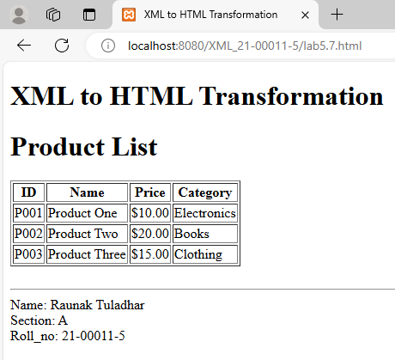

1. **Design an XML dataset representing a collection of books. Implement XQuery to retrieve specific information from the XML dataset, such as titles or authors, and display the results on a webpage.**

<!DOCTYPE html>

<html lang="en">

<head>

<meta charset="UTF-8">

<meta name="viewport" content="width=device-width, initial-scale=1.0">

<title>XML Data Retrieval</title>

<script>

document.addEventListener('DOMContentLoaded', function () {

const xmlString = `<?xml version="1.0" encoding="UTF-8"?>

<Library>

<Book id="B001">

<Title>The Great Gatsby</Title>

<Author>F. Scott Fitzgerald</Author>

<Year>1925</Year>

</Book>

<Book id="B002">

<Title>To Kill a Mockingbird</Title>

<Author>Harper Lee</Author>

<Year>1960</Year>

</Book>

<Book id="B003">

<Title>1984</Title>

<Author>George Orwell</Author>

<Year>1949</Year>

</Book>

<Book id="B004">

<Title>The Catcher in the Rye</Title>

<Author>J.D. Salinger</Author>

<Year>1951</Year>

</Book>

</Library>`;

document.getElementById('xmlData').textContent = xmlString;

const parser = new DOMParser();

const xmlDoc = parser.parseFromString(xmlString, 'application/xml');

const titles = xmlDoc.evaluate('//Title', xmlDoc, null, XPathResult.ORDERED_NODE_SNAPSHOT_TYPE, null);

const titlesArray = [];

for (let i = 0; i < titles.snapshotLength; i++) {

titlesArray.push(titles.snapshotItem(i).textContent);

}

const authors = xmlDoc.evaluate('//Author', xmlDoc, null, XPathResult.ORDERED_NODE_SNAPSHOT_TYPE,

null);

const authorsArray = [];

for (let i = 0; i < authors.snapshotLength; i++) {

authorsArray.push(authors.snapshotItem(i).textContent);

}

document.getElementById('titles').textContent = 'Titles:\n' + titlesArray.join('\n');

document.getElementById('authors').textContent = 'Authors:\n' + authorsArray.join('\n');

});

</script>

</head>

<body>

<h1>Book Data Retrieval</h1>

<h2>Raw XML Data</h2>

<pre id="xmlData"></pre>

<h2>Extracted Data</h2>

<pre id="titles"></pre>

<pre id="authors"></pre>

<br>

<hr>

<footer>

Name: Raunak Tuladhar <br>

Section: A <br>

Roll_no: 21-00011-5

</footer>

</body>

</html>

**Output:**

